MLC PROCEDURES
MANUAL

xxxxxx
IMO 9xx1767

Prepared by- Company MLC Officer

xxxxxxxxx PVT LTD

LIST OF REVISIONS

№ | Page | Item | Revision | Date of Revision | Distributed to | Approved by (Name / Signature)
1.
2.
3.
4.
5.
6.
7.
8.
9.
10.
11.
12.
13.
14.
15.
16.
17.
18.
19.
20.
21.
22.
23.

INDEX

MLC PROCEDURES
No. of Procedure | Name of Procedure | Page
MLC-PR-01 | MLC Implementation | 6
01.7.1 | Laws & Regulations (Flag Requirements & Contact Points) | 7
01.7.2 | Company MLC Policy | 10
01.7.3 | Master’s Overriding Authority | 11
01.7.4 | Company MLC Officer (CMO) | 12
01.7.5 | Ship MLC Officer (SMO) | 13
01.7.6 | Vessel’s Certification | 14
01.7.7 | Document. Control & Record Keeping | 15
01.7.8 | Inspections | 15
01.7.9 | Definitions | 16
MLC-PR-02 | Minimum Requirements for Seafarers | 18
02.7.1 | Introduction | 19
02.7.2 | Minimum Age | 19
02.7.3 | Medical Certification | 20
02.7.3.1 | Minimum Standards regarding Medical Certification | 20
02.7.3.2 | Medical Certificate | 21
02.7.3.3 | Qualified Medical Practitioners | 21
02.7.3.4 | Seafarer Physical Condition Requirements | 23
02.7.4 | Qualification of Seafarers | 27
MLC-PR-03 | Seafarer Awareness, Training & Evaluation | 28
03.7.1 | Familiarization | 29
03.7.2 | Training | 31
03.7.3 | Evaluation | 34
MLC-PR-04 | Manning Agent Control | 35
MLC-PR-05 | Seafarers’ Employment Agreements | 37
- | Sample of Seafarers’ Employment Agreement | 42
MLC-PR-06 | Payment of Wages | 42
MLC-PR-07 | Manning Levels, Hours of Work/Rest | 51
07.7.1 | Manning Level | 52
07.7.2 | Hours of Work & Rest | 53
MLC-PR-08 | Accommodation and Recreational Facilities | 55
MLC-PR-09 | Food & Catering | 57
09.7.1 | Requirements to Food & Catering | 58
09.7.2 | Ship’s Cook | 68

MLC-PR-10 | Medical Care | 70
10.7.1 | Medical Care Onboard | 72
10.7.2 | Shipowner Liability | 72
MLC-PR-11 | Drugs & Alcohol | 74
MLC-PR-12 | Health & Safety Protection and Accident Prevention | 78
MLC-PR-13 | Entitlement to Leave & Loss of Ship or Foundering Compensation | 81
13.7.1 | Entitlement to Leave | 82
13.7.2 | Loss of Ship or Foundering Compensation | 82
MLC-PR-14 | Seafarer Repatriation | 83
MLC-PR-15 | Onboard Complaints | 85
MLC-PR-16 | Financial security for repatriation (Regulation 2.5) | 88
MLC-PR-17 | Financial security relating to shipowners’ liability (Regulation 4.2 | 90
 | Familiarization list | 92

MLC
PROCEDURES

  - Objectives
MLC-PR-01 MLC IMPLEMENTATION

To ensure that the MLC is properly maintained onboard.

Scope
This procedure applies to all vessels managed by the company.

Responsibilities
Master is responsible for the implementation of this procedure onboard.

References
None

Regulations
ILO MLC
Marine Notice , MLC-001

Related Forms
- Safety Management System. С/L B2 (MFM01) Sec. 2.3.3 – Onboard familiarization checklist.
- MLC-F-01 & F-02 MLC Familiarization
- MLC-F-08 MLC Audit Report

Procedure Content

    - Laws and Regulations (Flag Requirements & Contact Points)
Through Executive Decree No. 86 of February 22, 2013, the National Legislation on the Maritime Labour Convention, MLC, 2006 was adopted and extensively discussed in tripartite sessions where representatives of seafarers, shipowners and the Panama Maritime Authority participated.
From March 11, 2013, the International Technical Office of Segumar Panama shall issue at no cost, the Declaration of Maritime Labour Compliance, Part I, (DMLC-Part I) in digital format where the national regulations required to certificate the vessel in accordance to the guidelines of the Maritime Labour Convention 2006, are regulated.
The Segumar offices in New York, Greece, Korea, Singapore and Tokyo shall start issuing the DMLC, Part I, by the end of March, 2013.
Vessels with a gross tonnage of 500 GT or more, engaged in international voyages, and those with a gross tonnage equal or over 500 GT flying the Panamanian flag and operating from a port, or between ports from another country, must have on board and in a visible place a copy of the Maritime Labour Convention and the Maritime Labour Certificate complemented with the Declaration of Maritime Labour Compliance, which consists of two parts, DMLC-Part I and DMLC-Part II.
In accordance with the MLC 2006, the term “international voyage” refers to a voyage from a country to a port located outside such country.
Vessels with a gross tonnage from 200 GT to 499 GT engaged in international voyages or voyages between ports, may voluntarily request the Maritime Labour Certificate, for which compliance with all national regulations shall be required.
Once the DMLC Part I is issued, the shipowner shall complete the Declaration of Maritime Labour Compliance Part II (DMLC-Part II), indicating the actions taken in order to ensure permanent compliance with the national requirements during the periods between surveys, as well as the measures proposed for guaranteeing continuous improvement of the aspects subject to survey.
That a recognized organization (RO) authorized by the Panama Maritime Authority, shall endorse the Declaration of Maritime Labour Compliance Part II (DMLC-Part II), once the full inspection has ended in accordance to the requirements of the MLC, 2006; and shall proceed to issue the Maritime Labour Certificate valid for five (5) years from the date of completion of the inspection on which this Certificate is based, in accordance to the MLC, 2006.
The shipowners to whose vessels were conducted a full inspection, as per Regulation 5.1.3 of the Maritime Labour Convention, MLC, 2006, at the time of publication of this circular, are entitled to request the DMLC, Part I; proceed with the corresponding processing and use the inspection report to immediately issue the certificate valid for five (5) years from the date of completion of the inspection which shall be issued by a recognized organization authorized by the Panama Maritime Authority.
If a vessel under the Panama Flag is properly certified in accordance with the guidelines of the MLC, 2006 and it changes name or suffers any substantial changes to the structure or equipment covered in Title 3 Standard A3.1, it must request the DMLC-Part I to the administration and the shipowner must prepare the DMLC- Part II, in order to process the renewal of the maritime labour certificate.
The DMLC Part II must include the vessel name, the IMO number and the gross tonnage in accordance to the template given by the administration.
There shall only be one DMLC Part I template for all vessel categories under the Panama Ships Registry.

The recognized organizations authorized shall only act in accordance to the guidelines provided by the Resolution, which authorizes them in matters related to the Maritime Labour Convention, 2006.

DEFINITIONS (ACCORDING TO NATIONAL REGULATIONS).

The term Seafarer or Seaman refers to “Any person, including the master, who is employed or engaged or works in any capacity on board a ship”.
If there is any doubt related to the condition of seafarer of any person category, the matter shall be resolved by the Panama Maritime Authority, upon corresponding consultation with the shipowners organizations and seafarers concerned.
As per national regulations, the following persons or category of persons are not considered as seafarers:

- Port pilots
- Port workers
- Ship Surveyors
- Superintendents
- Workers subject to the special working regime of the Panama Canal Authority.
- Technical staff operating offshore drilling platforms or MODU; except those individuals that because of their training and qualifications, are covered by the provisions of the STCW
- Convention.
- Armed personnel
- Scientists
- Researchers
- Divers
- Specialist off-shore technicians, and others whose work is not part of the routine operation of the ship
- Any other person or category of persons as indicated by the Administration.

Also, national regulations defines a Cadet as “An aspiring merchant marine officer, whose training program includes the improvement of academic and professional skills, as well as the formation of attitudes and behaviors under the observance and strict compliance of rules, regulations and existing orders.”
A Shipowner “is any natural or legal person, owner of a ship or another organization, such as the manager, agent or bareboat charterer, who has assumed the responsibility for the operation of the ship from the owner and who, on assuming such responsibility, has agreed to take over the duties and responsibilities imposed on shipowners in

accordance with the Maritime Labour Convention, (MLC, 2006) regardless of whether any other organization or persons fulfill certain of the duties or responsibilities on behalf of the shipowner”.
That the working relationships on board Panamanian flagged vessels exclusively navigating within interior waters, regardless of the patent type, shall be regulated by the provisions of the Decree Law No. 8 of 1998 whereby work at sea and in navigable waterways is regulated.

Company MLC Policy

The Company is committed to:

- provide the vessel with crew members not younger than 18 years old (MLC-PR-02);

- provide the vessel with medically fit crew members (MLC-PR-02);

- provide the vessel with properly qualified crew members (MLC-PR-02);

- provide the crew members with Seafarers’ Employment Agreement that corresponds to all requirements of MLC, 2006 providing decent conditions of employment (MLC-PR-05);

- use any licensed or certified or regulated private recruitment and placement service (MLC-PR-04);

- establish the following limits on hours of work or rest (MLC-PR-07) :
- maximum hours of work not exceeding 14 hours in any 24-hour period and 72 hours in any seven-day period
- minimum hours of rest not less than 10 hours in any 24-hour period and 77 hours in any seven- day period;

- provide ship manning in accordance with Minimum Safe Manning Certificate issued by competent authority (MLC-PR-07);

- provide the crew members with decent accommodation conditions (MLC-PR-08);

- provide the crew members with on-board recreational facilities (MLC-PR-08);

- provide the crew members with good quality food and drinking water provided under regulated hygienic conditions (MLC-PR-09);

- protect the health of seafarers and ensure their prompt access to medical care on board ship and ashore (MLC-PR-10);

- ensure that seafarers are protected from the financial consequences of sickness, injury or death occurring in connection with their employment (MLC-PR-10);

- ensure that seafarers’ work environment on board ships promotes occupational safety and health;

- provide the seafarers with payment for their work in time as established in MLC, 2006 and in the Company (MLC-PR-06);

- provide the crew members the on-board procedure for the fair, effective and expeditious handling of seafarer complaints alleging breaches of the requirements of MLC, 2006 (MLC-PR-15).

Master’s Overriding Authority

The master is the Company’s high official and authorized person on the ship. He bears full responsibility for the safe operation of the ship, the safety of shipboard personnel, the fulfilment of MLC, 2006 requirements on board.

The master handles the ship on the basis of undivided authority and is subordinate directly to the Managing Director or to the person appropriately authorized. The instructions related to the ship activities are given only to the master who is responsible for their execution.

All members of the shipboard personnel (crew) are appointed on the ship with the master’s consent. He has the right not to admit on board any person if his (her) documents do not meet the requirements of the international or national standards (rules and regulations) and particularly the requirements of MLC, 2006.

The master has the overriding authority to make decisions on ensuring safe operation of the ship and requesting the Company’s assistance. He is not limited in his right to make on his own responsibility any decisions adequate, in his view, to the established situation on ensuring safety of the ship, shipboard personnel, prevention of accident, protection of health of seafarers and the Company will encourage him in that. The Company is immediately informed about such decisions taken by him.

Company MLC Officer (CMO)

The Company MLC Officer (CMO) is responsible for the development of measures and implementation of company procedures according to MLC requirements in order to promote the health, safety and wellbeing of crew members. More specifically he:

- prepares, develops and implements MLC Procedures on shipboard;

- organizes and coordinates the fulfillment of MLC Procedures on shipboard;

- carries out MLC training for crew members on ship board;

- prepares MLC Forms that should be completed on-board by crew members particularly by Ship MLC Officer and after sent to the Company office in order to keep reporting system in order;

- maintains a constant link with ships, monitors condition of work of crew members;

- controls work & rest hours on shipboard in accordance with regulation of MLC, 2006 and STCW;

- prepares and develops Seafarers Employment Agreement draft for further signing between seafarer and shipowner in accordance with requirements of MLC, 2006;

- considers seafarers’ complaints and reports them to the top management;

- holds operative meetings on considering reports about revealed non-conformities, on taking decisions and execution of measures (urgent ones if required) on their removal (with pointing out concrete executors);

- organizes systematic internal and external MLC audits rectifying revealed non-conformities and carrying out corrective actions;

- prepares systematic reviews (analyses) of MLC Procedures taking into consideration requirements of MLC, 2006, its possible further amendments and needs of crew members engaged on company’s vessels.

The Company MLC Officer constantly contacts with Masters & Ship MLC Officers & shore based divisions mangers including private recruitment and placement services providers in case if their services are used.

The Company MLC Officer should be suitably qualified, competent and have experience in shipping business, should have the good knowledge and understanding of Maritime Labour Convention, 2006.

COMPANY MLC OFFICER

Capt. Sudhir Kumar Minocha
Name, last name

cso@oceanpack-shipmanagement.com
Contact details

Ship MLC Officer (SMO)

The Shipboard MLC officer role shall be a positive one, seeking to initiate or develop measures and implement MLC Procedures developed by the Company in order to promote the health, safety & wellbeing of the crew. More specifically he:

- cooperates with Company MLC Officer in respect of implementation of the requirements of MLC, 2006;

- promotes Company MLC Policy on shipboard;

- takes part in Shipboard Safety Committee Meetings, dealing with the questions of MLC, 2006, particularly condition of accommodation, proposals for improvement of onboard recreational facilities, quality food and water, health and safety, accident prevention;

- represents interests of seafarers, passes their complaints to CMO if it turns out not possible to solve them onboard;

- follows the completion of MLC forms and submits the reports to the Company office according to established time table;

- inspects the condition of working and living spaces whether they are clean and safe; completes relevant reporting forms;

- inspects the cleanliness of the galley;

- carries out occupational safety and health inspection;

- carries out necessary MLC Training on board for seafarers;

- completes the records of Hours of Work-Rest for each seafarer;

- carries out MLC Familiarization for new assigned crew members;

- keeps Seafarer Injury & Illness Medical Record.

The Shipboard MLC Officer constantly maintains the connection with CMO.

The Shipboard MLC Officer should have good knowledge and understanding of requirements of MLC, 2006. If it is necessary, CMO carries out for a new assigned SMO the required MLC training before embarkation.

The Shipboard MLC Officer is appointed by the Company’s order.

Company designated the Master as the SMO.

    - Vessel’s Certification

Vessel is certified for compliance with MLC requirements according to the following scheme:
Issuance of interim ML Certificate (6 months validity)
Shipowner applies to Flag/RO to carry out MLC inspection

Flag prepares DMLC Part I

A full term ML Certificate is issued with maximum validity of 5 years
MLC inspection is carried out by Flag State/RO

ML Certificate is the subject to an intermediate inspection between second and third anniversary dates of the certificate. ML Certificate is endorsed following satisfactory intermediate inspection.
Shipowner prepares DMLC Part II and submits it for approval by Flag State/RO

The renewal inspection is carried out within three months before the expiry of the existing ML Certificate.

Originals of ML Certificate and DMLC Part I and Part II shall be kept onboard in a separate file always at the disposal of Inspectors, Port Authorities, Agents, Class Surveyors. They are properly handed-over by the relieving Master and are given to the Port authorities when required.

Document Control & Record Keeping

All documents and changes (corrections) introduced into them as well as their new editions are approved (signed) by the Director (or an authorized person). Registration, publishing, keeping, distribution and sending documents is carried out by the MLC Department. Correction of the documents is performed by replacement of the whole manual, changes are registered in the list of revisions in the beginning of the manual. Recipients remove old documents and start to use new ones. The removed (obsolete) documents are sent to the MLC Department as confirmation of the removing done. Control copies of these documents are to be filed; other ones are to be destroyed. Documents and their correction are sent with a cover letter. The number and date of an out coming letter for each addressee are fed into a computer. The number and date of an incoming letter confirming the replacement are fed into the same computer. If the confirmation was not received from anybody after an established period, then an individual inquiry is sent.

The Company recognizes the importance of forms & checklists to assist the Master and Officers in the routine operation of their ship.

Check-list & Forms are contained in the Part 2 of this Manual. They are completed in time in accordance with time schedule stated on each form or check-list and submitted to the office in accordance with MLC Forms Matrix. Completed Check-lists & forms are kept onboard during three years and after are handled over to the Company office in order to be archived. Both Company and Ship have the folder “MLC Documentation”, where all MLC documents (except ML certificate and DMLC) and MLC records are kept.

Inspections

Vessel is the subject for internal and external inspections for compliance with MLC Requirements. Internal Audit is carried out onboard by Company MLC Officer in cooperation with Ship MLC Officer. The relevant form MLC-F-08 MLC Audit Report is completed in two copies, one for ship and another for office use. Internal MLC Audit is carried out once per year if there are no other requirements from Flag State/RO or the Port Authorities do not impose any major non- conformities connected with MLC on the vessel. The first internal audit is carried out after implementation of MLC Procedures onboard.
External Audits are carried out in accordance as described in Section 7.6 Vessel’s Certification of MLC-PR-01.

Definitions

Competent authority means the minister, government department or other authority having power to issue and enforce regulations, orders or other instructions having the force of law in respect of the subject matter of the provision concerned.

Company means the company that is responsible for managing the vessel including development and implementation MLC requirements on the vessel.

Crew Contract - the agreement between the company and the seafarer.

Declaration of Maritime Labour Cmpliance means the document stating the national requirements implementing the MLC, 2006 for the working and living conditions for seafarers and setting out the measures adopted by the shipowner to ensure the compliance with the requirements on the ship or ships concerned.

Gross tonnage means the gross tonnage calculated in accordance with the tonnage measurement regulations contained in Annex I to the International Convention on Tonnage Measurement of Ships, 1969, or any successor Convention; for ships covered by the tonnage measurement interim scheme adopted by the Inter- national Maritime Organization, the gross tonnage is that which is included in the REMARKS column of the International Tonnage Certificate (1969);

Hours of work means time during which a seafarer is required to do work on account of the
ship.

Hours of rest means time outside hours of work; this term does not include short breaks.

Manning Agreement - the agreement between the company and the ship manager/ owner.

Maritime Labour Certificate means the certificate certifying that the working and living conditions of seafarers on the ship, including measures for ongoing compliance to be included in the declaration of maritime labour compliance, have been inspected and meet the requirements of national law or regulations or other measures implementing this Convention.

Member of Convention means the countries that have ratified the Convention.

MLC, this Convention means Maritime Labour Convention that has been designed to become a global legal instrument of the international regulatory regime for quality shipping. It sets out seafarer’s rights to decent conditions of work and helps to create conditions of fair competition for shipowners.

Overtime means working hours in addition to those of a regular schedule.

Recognized Organization – in the MLC, 2006 the organizations to which the Flag States tasks can be delegated. In many countries the organizations that are authorized as ROs are ship classification societies that are also responsible for ship surveys including statutory certification of ships under IMO Conventions.

Seafarer means any person who is employed or engaged or works in any capacity on board a ship to which this Convention applies;

Seafarers’ employment agreement includes both a contract of employment and articles of agreement;

Seafarer recruitment and placement service means any person, company, institution, agency or other organization, in the public or the private sector, which is engaged in recruiting seafarers on behalf of shipowners or placing seafarers with shipowners;

Ship means a ship other than one which navigates exclusively in inland waters or waters within, or closely adjacent to, sheltered waters or areas where port regulations apply;

Shipowner The owner of the ship or another organization or person, such as the manager, agent or bareboat charterer, who has assumed the responsibility for the operation of the ship from the owner and who, on assuming such responsibility, has agreed to take over the duties and responsibilities imposed on shipowners in accordance with MLC, 2006, regardless of whether any other organization or persons fulfill certain of the duties or responsibilities on behalf of the shipowner

MLC-PR-02 MINIMUM REQUIREMENTS FOR SEAFARERS

Objectives
To ensure that all minimum requirements with respect to Age, Medical Certification and Qualification of Seafarers are being met in line with MLC requirements and to ensure that employed seafarers meet the Company standards.

Scope
This procedure applies to all seafarers employed on all vessels managed by the Company.

Responsibilities
Master is responsible for the proper implementation of this procedure onboard.

References
- STCW Code
- ILO / WHO Guidelines for Conducting Pre-sea and Periodic Medical Fitness Examinations for Seafarers

  - Regulations ILO MLC Regulation 1.1. ILO MLC Regulation 1.2. ILO MLC Regulation 1.3.

Related Forms
- MLC-F-03 Shipboard Working Arrangements & Records of Hours of Rest
- MFM/01-10.8.4 C/L. No. B-20. Table for Shipboard Working Arrangements.
- MFM/01-10.8.4 C/L. No. B-21. Records of Hours of Works

Procedure Content

    - Introduction

The purpose of this procedure is to ensure that seafarers employed by the Company are medically fit to perform their duties, not younger than 18 years old, are trained or qualified to carry out their duties on board ship.

Minimum Age

No person below the minimum age is employed or engaged or work on a ship. The minimum age at the time of the initial entry into force of Convention is 18 years. Night work of seafarers under the age of 18 is prohibited. Nightwork covers a period of at least nine hours starting no later than midnight and ending no earlier than 5 a.m. The employment, engagement or work of seafarers under the age of 18 is prohibited where the work is likely to jeopardize their health or safety.

It is the Company’s policy that no person below 18 years of age shall be employed or engaged or work onboard Company vessels.

The personnel department in coordination with the manning agents is responsible to monitor and implement this policy.

Nightwork is prohibited for seafarers under age 18.

Medical Certification

      - Minimum Standards Regarding Medical Certification

The competent authority requires that, prior to beginning work on a ship, seafarers hold a valid medical certificate attesting that they are medically fit to perform the duties they are to carry out at sea.

The medical certificate shall be issued by a duly qualified medical practitioner or, in the case of a certificate solely concerning eyesight, by a person recognized by the competent authority as qualified to issue such a certificate. Practitioners must enjoy full professional independence in exercising their medical judgment in under- taking medical examination procedures.

Seafarers that have been refused a certificate or have had a limitation imposed on their ability to work, in particular with respect to time, field of work or trading area, shall be given the opportunity to have a further examination by another independent medical practitioner or by an independent medical referee.

Each medical certificate shall state in particular that:

. (a) the hearing and sight of the seafarer concerned, and the color vision in the case of a seafarer to be employed in capacities where fitness for the work to be per- formed is liable to be affected by defective color vision, are all satisfactory; and

. (b) the seafarer concerned is not suffering from any medical condition likely to be aggravated by service at sea or to render the seafarer unfit for such service or to endanger the health of other persons on board.

Unless a shorter period is required by reason of the specific duties to be performed by the seafarer concerned or is required under STCW:

. (a) a medical certificate shall be valid for a maximum period of two years unless the seafarer is under the age of 18, in which case the maximum period of validity shall be one year;

. (b) a certification of color vision shall be valid for a maximum period of six years.

In urgent cases the competent authority may permit a seafarer to work with- out a valid medical certificate until the next port of call where the seafarer can obtain a medical certificate from a qualified medical practitioner, provided that:

. (a) the period of such permission does not exceed three months; and

. (b) the seafarer concerned is in possession of an expired medical certificate of recent date.

If the period of validity of a certificate expires in the course of a voyage, the certificate shall continue in force until the next port of call where the seafarer can obtain a medical certificate from a qualified medical practitioner, provided that the period shall not exceed three months.

The medical certificates for seafarers working on ships ordinarily engaged on international voyages must as a minimum be provided in English.

Medical Certificate

It is the Company’s policy that no seafarers work onboard Company’s vessels, unless they hold a valid medical certificate attesting that they are medically fit to perform their duties onboard.
The personnel department in coordination with the manning agents, as well as the vessel’s Master are responsible to check and ensure that the medical certificates for all seafarers onboard Company’s vessels are issued as per above requirements.

Qualified Medical Practitioners

The competent authority should maintain a list of recognized medical practitioners to conduct medical examinations of seafarers and issue medical certificates. The competent authority should consider the need for medical practitioners to be personally interviewed and for clinic facilities to be inspected before authorization to conduct medical examinations of seafarers is given. A list of medical practitioners recognized by the competent authority should be made available to competent authorities in other countries, companies and seafarers’ organizations on request.

The competent authority, when developing guidance for the conduct of medical fitness examinations, should take into consideration that general medical practitioners may need more detailed guidance than medical practitioners with competence in maritime health.

In addition, the provision of an expert helpline can aid decision-making on novel or complex problems and can be a source of information that may be used to improve the quality of assessments.

The names of any medical practitioners whose recognition has been withdrawn during the previous 24 months should continue to be included, with a note to the effect that they are no longer recognized by the competent authority to conduct seafarers’ medical examinations.

A medical practitioner so recognized by the competent authority:

- should be a qualified medical practitioner currently accredited by the medical registration authority for the place where they are working; should be experienced in general and occupational medicine or maritime occupational medicine;

- should have knowledge of the living and working conditions on board ships and the job demands on seafarers in so far as they relate to the effects of health problems on fitness for work, gained wherever possible through special instruction and through knowledge based on personal experience of seafaring;

- should have facilities for the conduct of examinations that are conveniently situated for access by seafarers and enable all the requirements of the medical fitness examination to be met and conducted with respect for confidentiality, modesty and cleanliness;

- should be provided with written guidance on the procedures for the conduct of medical examinations of seafarers, including information on appeals procedures for persons denied a medical certificate as a result of an examination;

- should understand their ethical position as examining medical practitioners acting on behalf of the competent authority, ensuring that any conflicts with this are recognized and resolved;

- should refer any medical problems found, when appropriate, for further investigation and treatment, whether or not a seafarer is issued with a medical certificate; and

- should enjoy professional independence from shipowners, seafarers, and their representatives in exercising their medical judgement in terms of the medical examination procedures. Those employed by, or contracted to, a maritime employer or crewing agency should have terms of engagement which ensure that an assessment is based on statutory standards.

It is further recommended that such medical practitioners:

- should be provided with information on the standard of competence for seafarers designated to take charge of medical care on board ships in relevant national laws and regulations; and

- should be familiar with the latest edition of the International Medical Guide for Ships, or an equivalent medical guide for use on ships.

The competent authority should have in place quality assurance procedures to ensure that medical examinations meet the required standards. These should include publicized arrangements for:

- the investigation of complaints from shipowners, seafarers, and their representatives concerning the medical examination procedures and the authorized medical practitioners;

- collection and analysis of anonymized information from medical practitioners about the numbers of examinations undertaken and their outcomes; and

- the introduction, where practical, of a nationally agreed review and audit programme for examining medical practitioners’ practices and recordkeeping undertaken by, or on behalf of, the competent authority. Alternatively, they could endorse appropriate external clinical accreditation arrangements for those undertaking seafarers’ medical examinations, the results of which would be made available to the authority.

Recognized medical practitioners who are found by the competent authority as a result of an appeal, complaint, audit procedure, or other reasons to no longer meet the requirements for recognition should have their authorization to conduct seafarers’ medical examinations withdrawn.

Seafarer Physical Condition Requirements

Vision standards
All tests needed to determine the visual fitness of a seafarer are to be reliably performed by a competent person and use procedures recognized by the relevant national authority. Quality assurance of vision-testing procedures at a person’s first seafarer examination is particularly important to avoid inappropriate career decisions; competent authorities may wish to specify this in detail:

        - Distance vision should be tested using Snellen test type or equivalent.

        - Near vision should be tested with reading test type.

        - Color vision should be tested by color confusion plates (Ishihara or equivalent). Supplementary investigations such as lantern tests may be used when appropriate (see the International Recommendations for Color Vision Requirements for Transport of the International Commission on Illumination (CIE-143-2001, including any subsequent versions)). The use of color-correcting lenses will invalidate test results and should not be permitted.

        - Visual fields may initially be assessed using confrontation tests (Donders, etc.) and any indication of limitation or the presence of a medical condition where visual field loss can occur should lead to more detailed investigation.

        - Limitations to night vision may be secondary to specific eye diseases or may follow ophthalmological procedures. They may also be noted during other tests or found as a result of limitations to low-contrast vision testing. Specialist assessment should be undertaken if reduced night vision is suspected.

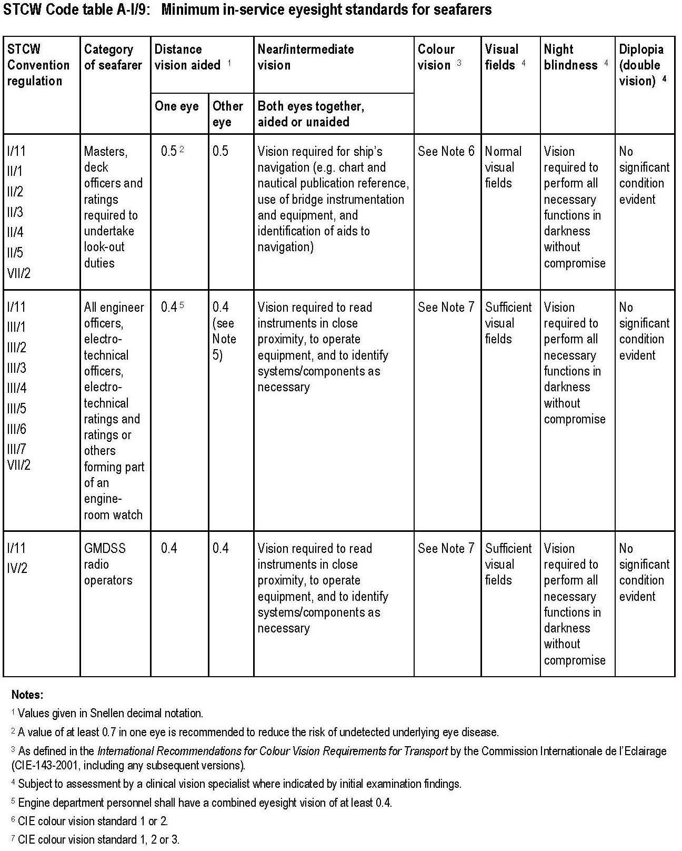

Visual correction
Medical practitioners should advise persons required to use spectacles or contact lenses to perform duties that they should have a spare pair or pairs, as required, conveniently available on board the ship.

Hearing standards
Hearing capacity for seafarers apart from those identified below should be an average of at least 30 dB (unaided) in the better ear and an average of 40 dB (unaided) in the less good ear within the frequencies 500, 1,000, 2,000 and 3,000 Hz (approximately equivalent to speech-hearing distances of 3 metres and
2 metres, respectively).

It is recommended that hearing examinations should be made by a pure tone audiometer. Alternative assessment methods using validated and standardized tests that measure impairment to speech recognition are also acceptable. Speech and whisper testing may be useful for rapid practical assessments. It is recommended that those undertaking deck/bridge duties are able to hear whispered speech at a distance of 3 metres.

Hearing aids are only acceptable in serving seafarers where it has been confirmed that the individual will be capable of safely and effectively performing the specific routine and emergency duties required of them on the vessel that they serve on throughout the period of their medical certificate. (This may well require access to a back-up hearing aid and sufficient batteries and other consumables.) Arrangements need to be in place to ensure that they will be reliably aroused from sleep in the event of an emergency alarm.

If noise-induced hearing loss is being assessed as part of a health surveillance programme, different criteria and test methods will be required.

It is recommended that national authorities indicate which tests for hearing are to be used, based on national audiological practices, using the above thresholds as criteria. Procedures should include the methods to be adopted in deciding if the use of a hearing aid is acceptable.

Physical capability requirements
The physical capability requirements for work at sea vary widely and have to take account of both routine and emergency duties. The functions that may require assessment include:

- strength;

- stamina;

- flexibility;

- balance and coordination;

- size – compatible with entry into confined areas;

- exercise capacity – heart and respiratory reserve; and

- fitness for specific tasks – wearing breathing apparatus.

Medical conditions and physical capability
Limitations may arise from a range of conditions, such as:

- high or low body mass/obesity;

- severely reduced muscle mass;

- musculoskeletal disease, pain or limitations to movement;

- a condition following an injury or surgery;

- lung disease;

- heart and blood vessel disease; and

- some neurological diseases.

Qualification of Seafarers.

The Company has established procedures in order to ensure that only those seafarers are employed who are trained or certified as competent or otherwise qualified to perform their duties in accordance with STCW and appropriate Flag state requirements.

The Personnel Manger is responsible for ensuring that all national, international, flag state and Company requirements are followed.

In the case that a situation arises where a deviation from an additional non-statutory Company requirement becomes necessary, then such a deviation has to be agreed with the Designated Person Ashore on a case-by-case basis.

A deviation from the statutory requirements is only acceptable when the appropriate authority gives permission hereto and when it is in agreement with the Designated Person Ashore. When such a deviation becomes necessary – e.g. in case of illness – all efforts should be made to bring the vessel’s manning in accordance with the requirements again as soon as possible.

Certification requirements for each vessel are given on the checklists enclosed within this procedure.

The Master checks the crew certification and sends the checklist (Officer and Crew Certification and Officers Qualification and Experience Matrix) to the Personnel Department on a monthly basis.

MLC-PR-03 SEAFARER AWARENESS, TRAINING & EVALUATION

Objectives
To ensure that:
    - seafarers boarding vessel are properly familiarized to Company standards;
    - new seafarers joining the company’s ships receive necessary familiarization in accordance with their duties and Company’s SMS;
    - the performance of all seafarers employed by the Company is consistently monitored & evaluated;
    - training needs in support of SMS can be effectively identified and satisfied while a suitable training program is established;
    - seafarers have an adequate understanding of rules, regulation codes, and other relevant guidelines related to SMS.

Scope
This procedure applies to all seafarers employed on the vessels managed by the company.

Responsibilities
Master is responsible for the implementation of this procedure onboard.

References
Safety Management System. Pre-joining. Familiarization and Training.

Regulations
ISM Code ILO MLC

Related Forms
- MFM 01- SEC 2.2.3 C/L. No. B2 – Onboard familiarization checklist
- SMS Main Manual (MQS) C/L. No. A.11(a) Officer’s appraisal report
- SMS Main Manual (MQS) C/L. No. A 11 (b) – Rating’s appraisal form
- SMS Main Manual (MQS) C/L. No. A 11 (c) – Officer’s and crew evaluation report
- MFM 04 Sec. 2.2.3 C/L. No. BPM 04 – Bridge familiarization
- MFM 01- SEC 2.2.3 C/L. No. B6 – Training card
- PDM – Sec 1.3 C/L. No. PDM-01 – Certificate of Handing over (Master)
- PDM – Sec 9.3 C/L. No. PDM-02 – Certificate of Handing over (Chief Engineer)
- PDM – Sec 2.3/3.3/4.3 C/L. No. PDM-03 – Certificate of Handing over (Deck officer)
- PDM – Sec 10.3/11.3/13.3/14.3/15.3/16.3 C/L. No. PDM-04 – Certificate of Handing over (Engineer)
- MLC-F-01 Galley Department Familiarization
- MLC Familiarization List

Procedure content

    - Familiarization

In order to ensure that the new personnel, or the personnel transferred to a new assignment, receive proper familiarization with their duties, every person joining the vessel has to be given instructions according to the following procedure:

All persons joining the vessel, regardless of if they are crewmembers or not, have to be instructed in the use and locations of life saving appliances according to checklist: Familiarization - Safety Arrangements (48 hrs). The Safety officer will be responsible for familiarizing the newly joining persons within 48 hours of joining but before departure (24 hours if more than 25 % of crew was changed). The Ship Security Officer will instruct them of ship’s security general rules. The Ship MLC Officer will instruct on MLC requirements and how they are implemented on ship.

An officer appointed by the Master will be responsible for the familiarization of the newly joining crew with the vessel in general. This familiarization has to include, but is not limited to:

- The arrangements of alleyways, emergency exits and escape routes.

- Mess rooms and public sanitary installations.

- Restrictions in use of sanitary equipment, if applicable.

- General regulations on behavior on board.

- General safety matters.

The Chief Officer and the Chief Engineer Officer are responsible for the familiarization in their departments respectively. The familiarization has to include, but is not limited to:

- Rules and regulations regarding safety at work.

- Communication systems including emergency communication and signaling.

- System of permits for hazardous work.

- Use of power tools and machinery.

- Correct clothing.

The Ship Security Officer is to familiarize newly joined crewmembers with the Ship Security Plan respectively to their duties. The familiarization has to include, but is not limited to:

- Structure of security organization

- Ship’s security levels

- Possible threats

- Security duties

- Communication for security and reporting suspicious persons, objects or activities

- Ship’s restricted areas, access to restricted spaces

- Controlling, identification of embarkation of persons

- Supervising the handling of cargo and stores delivery

All crewmembers must be aware, that security duties and procedures are confidential.

Training

The adoption of training programs for personnel is dependent on the funding availability provided by Owners for each vessel, together with the resources available within Company When in place, training regimes will be advised separately to each vessel and may include the provision of specific onboard courses and onshore training.

The Marine & Safety Manager will define the training requirements in consultation with the Personnel Department, who will be arrange for the training courses.

It is the responsibility of individual officers to ensure that their required certificates are valid and renewed as appropriate.

Safety Familiarization Program

Company recognizes the need for all seafarers joining a vessel to undertake a safety familiarization program. To ensure that this aspect is covered we require the Master / Shipboard Management Committee to adopt specific controls on this training. To avoid duplication, Masters should advise if the vessel's Owner / Technical Manager has instigated a similar program.

If properly administered this will give a good starting point for training onboard for the remainder of the seafarer's tour of duty.

Standard Onboard Training

Onboard training programs will be advised on an individual vessel basis and will be adapted to meet the vessel's specific requirements.

As an example a typical onboard training program may consist of:

- The supply to the vessel of a videotape-training course.

- Instructions to the Master / Shipboard management on the adoption and administration of the scheme.

- The appointment of a Responsible Officer as a designated Training Officer.

- Regular reports on the usage / effectiveness of the training program.

- Ship Visits by shore based training / safety officer.

The control of an onboard training scheme is the responsibility of the Shipboard Management Committee and a designated Training Officer, who will usually be a senior officer.

The validity of any program is dependent on the time and effort taken to make it work and the Shipboard Management Committee can use the resources of Company Personnel Department for assistance in the development and maintenance of the program.

Training as a Developmental Tool

Company has a policy of re-employing junior officers where they have good appraisal reports. This requires flexibility in relieves and rotations but does show a benefit in the continuity obtained and allows our senior officers to guide and control juniors who may serve in the Company fleet in the future.

There is no substitute for training 'on the job' and Company relies on the input of Masters and other senior staff in both assessing their junior officers and assisting them towards higher positions. In this respect senior staff onboard should allow subordinates every opportunity of practicing, under supervision, tasks associated with their higher rank.

Encouragement in this way will lead to a positive evaluation of the officers desires and potential and may be used to show up weaknesses which may require remedial onboard or onshore training.

Masters should encourage other senior officers to show this positive developmental approach to their subordinates.

The Master is responsible for the onboard training of the crew in the understanding of the SMS, and he must prepare a SMS training schedule for the vessel, stating how frequently the training should take place and the scope that the individual training sessions should have.

The practical training can be delegated to the Chief Officer or the Chief Engineer.

The training can be done together with weekly safety drills, or separate training sessions may be held as necessary.

As a minimum the crew should be introduced to the structure of the manuals, including where the manuals can be found onboard. In addition to this each group of crewmembers must receive detailed training in the understanding of procedures relevant for each individual group. This training should also include ship-specific procedures developed onboard, and training in relevant rules and regulations.

Any crewmember onboard has the authority to request additional training in all Chief Officers and 2nd Engineers, regardless of whether they are expected to be promoted in the near future or not, are to be trained in the duties of the next higher rank, in order to be able to take over from their respective superior in case he becomes incapacitated.

For Chief Officers the basic training should, as a minimum, consist of the following:

- Classification Society and Flag State Requirements

- SMS and Company Requirements

- Charter Party and related Requirements

- Port State Requirements

- Port Pre Entry Formalities

- Crew Management

- Vessel handling (If the Master deems it to be safe, the C/O should maneuver the vessel, take pilot, drop anchor etc.)

For 2nd Engineers the basic training should, as a minimum, consist of the following:
- Classification Society and Flag State Requirements

- Company administrative routines including the understanding of the Chief Engineer’s duties as per the SMS manual and reporting procedures,

- Company purchasing procedures,

- Planned maintenance, including the use of Company software.

- The daily management of the engine department.

- Oil Record Book requirements.

SMS Forms shall be completed and forwarded to the Personnel Department. Additional Training For C/O’s Prior to Promotion When an officer has been identified by the Company as suitable for promotion from a combination of appraisal reports, letters of recommendation, Superintendent appraisal reports and any additional reports from serving Masters then the Company will ensure a path to promotion will include the following:

- A period of intensive training at the Company offices

- An intensive handover and training period onboard

The need for an Industrial Psychological Assessment at Marine Profile or similar will be decided upon on a case to case base. Upon satisfactory completion of the intensive training onboard, the Master and/or Chief Engineer must confirm this in writing to the Company and if necessary an Officer Appraisal Report the understanding of the SMS.

Evaluation

Company recognizes that the continual appraisal of performance of all sea staff is essential for a proper evaluation of the potential for promotion and for the recognition of an individual’s problem areas. Company requires senior officers to participate fully in appraising their staff. Company manning agents are kept advised of the performance of their staff by copying personnel appraisals for their records.

The level of complexity of appraisals depends on the rank of the person being appraised and standard forms are in use for appraisals. It is also recognized that the proper evaluation of Masters can only be accomplished by the visiting Superintendent.

Masters and Chief Engineers are requested to forward appraisals for the shipboard staff quarterly. Appraisal reports, when received in the office, are read and signed by the Personnel Manager. All originals are then passed to the Personnel Officer for review prior to entering into the crew system, copying for the Manning Agent and filing in the man files. Senior staff reports (including Master, Chief Officer, Chief Engineer, and Second Engineer) for officers serving on technically managed vessels are also sighted by the Management, prior to being filed in the personnel files.

The senior officers onboard are encouraged to forward additional reports related to specific personnel matters. These are for the attention of the Personnel Manager who will take action as appropriate.

These assessment reports are normally to be discussed with the Officer onboard and his signature obtained prior to being dispatched to Company.

Supplied in a simpler format, these reports are not normally discussed with the ratings.

It has to be ensured that the crew manager provides Company with copies of the appraisal reports.

The Personal Assessment report contains recommendations for promotion from the Master / Chief Engineer. When promotions are required for senior ranks, the Personnel Manager should review all suitable candidates and assess the candidates in consultation with the technical staff.

Where junior officer promotions are required, the Personnel Manager will review reports / recommendations and promote the most suitable candidate. The report may also contain recommendations regarding promotion or further training and these comments are taken into account when the candidate is submitted for higher rank or training courses (e.g. Ship’s Cooks’ training).

Where a ‘Personal Assessment’ contains unfavorable reports, the Personnel Manager will review the actions taken by the onboard management and will assist them as required. Where Senior Officers have unfavorable reports, the actions taken will be discussed with technical and senior management.

Unfavorable reports are to brought to the attention of the manning agent and, if warranted, should be recorded as a manning agent non-conformance.

MLC-PR-04 MANNING AGENT CONTROL

Objectives
To ensure that seafarers have access to an efficient and well-regulated seafarer recruitment and placement service.

Scope
This procedure applies to all seafarers employed on the vessels managed by the company.

Responsibilities
Company Personnel Officer is responsible for implementation of this procedure.

References
Safety Management System. Recruitment and Selection.

Regulations
ILO MLC

Related Forms
None

Procedure content
In addition to officers recruited directly by Company, contracted manning agents supply officers. Prior to the scheduled relief, the Personnel Officer sends a communication to the manning agent confirming the ranks / dates required and port (if known) for that vessel. The manning agent will be requested to source suitable candidates and report with details.

For Senior Officers recruited through the manning agent and entered on the Senior Officers Advance Relief Planner, the Personnel Officer will keep in regular contact with the manning agent, in respect of their schedules. The manning agent is responsible for submitting candidates who conform to the vessel's Recruitment Criteria or, when proposing candidates who do not meet the Recruitment Criteria, for advising the Personnel Department accordingly.

The manning agent will report details of nominated candidates. The agent should provide details which include: the candidate s name, date and place of birth, passport number / issue / expiry, discharge book number / issue / expiry, license type and number, additional qualifications and short courses, and previous sea service. The manning agent should advise the Personnel Department, if the candidate is not in possession of a passport or seaman's book. Normally both documents are required prior to travelling. If the candidate has previous service onboard Company managed vessels, the Personnel Officer will check previous performance reports and, if satisfactory in terms of experience / qualification for rank and performance on- board the vessel(s), confirm acceptance to the Manning Agent. If the reports are not satisfactory, the Personnel Officer will reject the candidate and request an alternative. If the candidate has no prior service with Company, the Personnel Officer will request the agent to provide references or telephone contacts of previous employers before assessing suitability. Direct contacts to previous employers are to be made by Company whenever confirming references.

The MLC requires that “private seafarer recruitment and placement services whose primary purpose is the recruitment and placement of seafarers or which recruit and place a significant number of seafarers, they shall be operated only in conformity with a standardized system of licensing or certification or other form of regulation”.

“Shipowners, who use seafarer recruitment and placement services based in countries or territories in which the Convention does not apply, shall ensure, as far as practicable, that those services meet the requirements”.

In respect of above stated facts, the Company requires from all manning agents to provide it with the copy of Statement of Compliance confirming that the manning agent was voluntary certified in accordance with MLC requirements. This copy is attached to each SEA that was signed by a seafarer who was recruited by the manning agent.

MLC-PR-05 SEAFARERS’ EMPLOYMENT AGREEMENT

Objectives
To ensure that seafarers have a fair employment agreement.

Scope
This procedure applies to all seafarers employed on the vessels managed by the company.

Responsibilities
Company MLC Officer is responsible for implementation of this procedure.

References
MLC, Regulation 2.1

Regulations
ILO MLC

Related Forms
None

Procedure content

Clauses and or issues that should be addressed in a model Seafarers Employment Agreement (SEA) according to MLC requirements

- Name, date of birth or age and place of birth of seafarer

- Shipowner’s name and address

- Place where and date when the SEA is entered into

- Rank / capacity

- Wages (if applicable a formula used for calculation)

- Seafarers are paid monthly and in compliance with their employment agreements and collective bargaining agreement (if applicable).

- Seafarers receive a monthly account for their payments incl. wages, additional payments, deductions (e.g. allotments), and applied exchange rates (if applicable).

- Seafarers can request for remittance (allotment) of their entire earnings or part of their earnings to an account nominated by the seafarers.

- It is ensured that the requested allotment will be remitted at regular intervals and in due time.

- Charges for the service of allotment are reasonable in amount, if any.

For seafarers whose remuneration includes separate compensation for overtime worked:

- Does the calculation formula for basic pay satisfy the minimum requirement - the normal hours of work does not exceed 8 hours per day at sea or in port?

- Does the calculation formula for overtime satisfy the minimum requirement - the number of normal hours per week does not exceed 48 hours or as prescribed by the national law?

- Is the rate of compensation for overtime not less than one and one-quarter times the basic wage per hour (or as prescribed by the national law)?

- Are overtime records maintained at least monthly on board and endorsed by the seafarer?

For seafarers whose wages are fully or partially consolidated:

- the number of hours of work expected of the seafarer in return for this remuneration, and any additional allowances which might be due in addition to the consolidated wage;

- where hourly overtime is payable for hours worked in excess of those covered by the consolidated wage, the hourly rate should be not less than one and one quarter times the basic rate corresponding to the normal hours of work; the same principle should be applied to the overtime hours included in the consolidated wage;

- remuneration for that portion of the fully or partially consolidated wage representing the normal hours of work should be no less than the applicable minimum wage; and for seafarers whose wages are partially consolidated, records of all overtime worked should be maintained and endorsed monthly

- Compensation for overtime or for work performed on the weekly day of rest and on public holidays by at least equivalent time off duty and off the ship or additional leave in lieu of remuneration or any other compensation so provided.

- on termination of engagement all remuneration due should be paid without undue delay;

- no deductions should be made from a seafarer’s remuneration in respect of obtaining or retaining employment;

- monetary fines against seafarers other than those authorized by national laws or regulations, collective agreements or other measures should be prohibited;

It is ensured that normal hours of work are based on an 8 hours day with 1 day of rest per week and rest on public holiday, meaning that each hour exceeding this period shall be considered as overtime.

Limits on applicable hours of work or hours of rest shall be determined according to MLC, 2006 requirements.

The amount of paid annual leave or, where applicable the formula used for calculation

- It is ensured that seafarers are provided with a sufficient amount of separately paid annual leave based on a minimum of 2.5 calendar days per month of employment. Justified absences (illness, injury, maternity, public and customary holidays, compensatory leave, short ashore leave) from work are not part of annual leave.

- The level of pay during annual leave should be at the seafarer’s normal level of remuneration

- no agreements exist that allows to forgo the minimum annual paid leave

The termination of the agreement and the conditions thereof, including:

(i). if the agreement has been made for an indefinite period, the conditions entitling either party to terminate it, as well as the required notice period, which shall not be less for the shipowner than for the seafarer;
(ii). if the agreement has been made for a definite period, the date fixed for its expiry; and
(iii). if the agreement has been made for a voyage, the port of destination and the time which has to expire after arrival before the seafarer should be discharged;

- Health and social security benefits

- The branches to be considered with a view to achieving progressively comprehensive social security protection are: medical care, sickness benefit, unemployment benefit, old-age benefit, employment injury benefit, family benefit, maternity benefit, invalidity benefit and survivors’ benefit

- The protection to be provided should at least include the branches of medical care, sickness benefit and employment injury benefit.
- SEA should identify the means by which the various branches of social security protection will be provided to the seafarer by the shipowner as well as any other relevant information at the disposal of the shipowner, such as statutory deductions from the seafarers’ wages and shipowners’ contributions which may be made in accordance with the requirements of identified authorized bodies pursuant to relevant

national social security schemes.
- Seafarers are entitled to adequate compensation in the case of injury, loss or unemployment arising from the ship’s loss or foundering.
- The indemnity against unemployment resulting from a ship’s foundering or loss should be paid for the days during which the seafarer remains in fact unemployed at the same rate as the wages payable under the employment agreement, but the total indemnity payable to any one seafarer may be limited to two months’ wages.
- seafarers are given health protection and medical care as comparable as possible to that which is generally available to workers ashore, including prompt access to the necessary medicines, medical equipment and facilities for diagnosis and treatment and to medical information and expertise;

- medical care and health protection services (while on board or in a port) are provided free of charge to seafarers;
- health protection and medical care, including essential dental care, are not limited to treatment of sick or injured seafarers but include measures of a preventive character
- shipowners shall be liable to bear the costs for seafarers in respect of sickness and injury of the seafarers occurring between the date of commencing duty and the date upon which they are deemed duly repatriated, or arising from their employment between those dates;
- shipowners shall be liable to defray the expense of medical care, including medical treatment and the supply of the necessary medicines and therapeutic appliances, and board and lodging away from home until the sick or injured seafarer has recovered, or until the sickness or incapacity has been declared of a permanent character;
- shipowners shall provide financial security to assure compensation in the event of the death or long- term disability of seafarers due to an occupational injury, illness or hazard, as set out in national law, the seafarers’ employment agreement or collective agreement;
- Where the sickness or injury results in incapacity for work the shipowner shall be liable: (a) to pay full wages as long as the sick or injured seafarers remain on board or until the seafarers have been repatriated in accordance with this Convention; and (b) to pay wages in whole or in part as prescribed by national laws or regulations or as provided for in collective agreements from the time when the seafarers are repatriated or landed until their recovery or, if earlier, until they are entitled to cash benefits under the legislation of the Member concerned.
- The payment of full wages required by Standard A4.2, paragraph 3(a), MLC may be exclusive of bonuses.
- National laws or regulations may limit the liability of the shipowner to pay wages in whole or in part in respect of a seafarer no longer on board to a period which shall not be less than 16 weeks from the day of the injury or the commencement of the sickness.

- National laws or regulations may limit the liability of the shipowner to defray the expense of medical care and board and lodging to a period which shall not be less than 16 weeks from the day of the injury or the commencement of the sickness.

Entitlement of repatriation

- The maximum duration of service periods on board following which a seafarer is entitled to repatriation shall be no less than 12 months

- Shipowners are prohibited from requiring that seafarers make an advance payment towards the cost of repatriation at the beginning of their employment, and also from recovering the cost of repatriation from the seafarers’ wages or other entitlements except where the seafarer has been found, in accordance with national laws or regulations or other measures or applicable collective bargaining agreements, to be in serious default of the seafarer’s employment obligations.

- Seafarers should be entitled to repatriation:

- in the case covered by Standard A2.5, paragraph 1(a), upon the expiry of the period of notice given in accordance with the provisions of the seafarers’ employment agreement;

- in the cases covered by Standard A2.5, paragraph 1(b) and

- :(i) in the event of illness or injury or other medical condition which requires their repatriation when found medically fit to travel;

- in the event of shipwreck;

- in the event of the shipowner not being able to continue to fulfill their legal or contractual obligations as an employer of the seafarers by reason of insolvency, sale of ship, change of ship’s registration or any other similar reason;

- in the event of a ship being bound for a war zone, as defined by national laws or regulations or seafarers’ employment agreements, to which the seafarer does not consent to go; and

- in the event of termination or interruption of employment in accordance with an industrial award or collective agreement, or termination of employment for any other similar reason.

- The costs to be borne by the shipowner for repatriation under Standard A2.5 MLC should include at least the following:

- passage to the destination selected for repatriation in accordance with paragraph 6 of this Guideline;

- accommodation and food from the moment the seafarers leave the ship until they reach the repatriation destination;

- pay and allowances from the moment the seafarers leave the ship until they reach the repatriation destination, if provided for by national laws or regulations or collective agreements;

- transportation of 30 kg of the seafarers’ personal luggage to the repatriation destination; and (e) medical treatment when necessary until the seafarers are medically fit to travel to the repatriation destination.

- Time spent awaiting repatriation and repatriation travel time should not be deducted from paid leave accrued to the seafarers

- Reference to CBA, if applicable - Not applicable

- National law requirements – see 05.4. References

.

  - Objectives
MLC-PR-06 PAYMENT OF WAGES

To ensure that seafarers are paid for their service.

Scope
This procedure applies to all seafarers employed on the vessels managed by the company.

Responsibilities
Company is responsible for implementation of this procedure.

References
SEA

Regulations
ILO MLC, Reg. 2

Related Forms
- Safety Management System Procedure Final Wage Account.xls

Procedure content

Crew are paid monthly, in accordance with their SEA and are given a monthly account of the payments due and the amounts paid, including wages, any additional payments, and the rate of exchange used (official bank’s daily rate) - if applicable.

The Company provides the seafarers with a means to transmit all or part of their earnings to their families or dependants or legal beneficiaries.The above means maybe established by the seafarer at the time of their entering employment or during it, if they so desire. The transfer of all or a proportion of the seafarer’s wages for remittance maybe by bank transfers or similar means at regular intervals.

All transmitting charges are paid by the Company at official rates.

Seafarers are entitled to receive, on demand, from the Master, wages actually earned, less any valid deductions, at any convenient port of call but not more than once in any fifteen-day period.

The normal working hours’ standard for seafarers are based on an eight-hour day with one day of rest per week and rest on public holidays. Any applicable CBA may determine seafarers’ normal working hours on a basis no less favorable than this.

Hours worked in excess of the normal working hours are considered overtime. The rate of compensation for overtime is not less than 1.25 of the basic wage per hour.

Overtime records are kept on board and endorsed by the crew. The records of overtime are consistent with the record of rest hours.

The Company or the Master pay to every crew their wages at the time when the crew is discharged and provide the crew with a final wages account.

Where a crew unlawfully refuses or neglects to work when required, the crew is not entitled to wages for that period. Where a crew is by reason of sickness incapable of performing his assigned duty and it is proved that such illness has been caused by the crew own willful act or default or is a sickness or illness concealed at the time of employment, the crew is not entitled to wages for the time during which the crew is by reason of the sickness, incapable of performing the assigned duty.

MLC-PR-07 MANNING LEVELS, HOURS OF WORK/REST

Objectives
- to ensure that seafarers work on board ships with sufficient personnel for the safe, efficient and secure operation of the ship;
- to ensure that seafarers have regulated hours of work or hours of rest.

Scope
This procedure applies to all seafarers employed on the vessels managed by the company.

Responsibilities
Company and Master are responsible for implementation of this procedure.

References
Merchant Marine Circular MMC No. 268 of Panama Maritime Authority

Regulations
ILO MLC
STCW Code

Related Forms
- MQS Sec. 6.2.3 C/L. No. A-7. OCIMF Officers Experience SIRE Matrix
- MLC-F-03 Shipboard Working Arrangements & Records of Hours of Rest
- MFM/01-10.8.4 C/L. No. B-20. Table for Shipboard Working Arrangements.
- MFM/01-10.8.4 C/L. No. B-21. Records of Hours of Works

Procedure Content

    - Manning Level

Company ensures that each vessel is sufficiently manned, at least in accordance with the Minimum Safe Manning Certificate, with qualified and certified seafarers in accordance with national, international and Company requirements.

The Personnel Manager is responsible for ensuring that all national, international, flag state and Company requirements are followed.

In the case that a situation arises where a deviation from an additional non-statutory Company requirement becomes necessary, then such a deviation has to be agreed with the Designated Person Ashore on a case-by-case basis.

A deviation from the statutory requirements is only acceptable when the appropriate authority gives permission hereto and when it is in agreement with the Designated Person Ashore. When such a deviation becomes necessary – e.g. in case of illness – all efforts should be made to bring the vessel’s manning in accordance with the requirements again as soon as possible.

Certification requirements for each vessel are given on the checklists enclosed within this procedure.

The Master checks the crew certification and sends the MQS Sec. 6.2.3 C/L. No. A-7. OCIMF Officers Experience SIRE Matrix to the Personnel Department on a monthly basis.

Hours of Work and Rest
The normal working hours’ standard for seafarers are based on an eight-hour day with one day of rest per week and rest on public holidays. Any applicable CBA may determine seafarers’ normal working hours on a basis no less favorable than this.

Furthermore, it is Company’s policy that if a seafarer’s normal rest period is disturbed due to call-outs to work or an immediate safety situation, this is to be adequately compensated and a relevant recording will be made in the official log book.

Moreover, planned drills onboard are conducted in a manner that minimizes the disturbance of rest periods and does not induce fatigue.

Merchant Marine Circular MMC - No. 268 of Panama Maritime Authority establishes the following requirements in respect of hours of rest onboard of ships flying Panama flag.

The minimum rest hours shall not be less than:

- ten (10) hours in any 24-hour period; and

- seventy seven (77) hours in any seven-day period.

Rest hours may be divided into no more than two periods, one of which shall be at least six (6) non- interrupted hours in length, and the interval between consecutive periods of rest shall not exceed fourteen (14) hours.

Exceptions to the minimum limits of rest hours for seafarers are allowed in accordance to Regulation
2.3.13 of the Maritime Labour Convention, 2006 (MLC,2006), as long as these are recognized within a collective agreement or adjusted to the provisions established in the International Convention on Standards of Training, Certification and Watchkeeping for Seafarers 78 (STCW, 78), Amended. It may be taken into account more frequent or longer leave periods or the granting of compensatory leave for watchkeeping seafarers or seafarers working on board ships on short voyages.

The master of a ship shall have the right to interrupt and suspend the rest hours of the seafarers whenever it is required:

- To ensure the immediate safety of the ship, persons on board or cargo, or to provide assistance to other ships or persons in distress at sea until the normal situation has been restored.

- To perform periodical exercises such as firefighting, lifeboat drills and others established by national and international regulations to be conducted in a manner that minimizes the disturbance of rest periods and does not induce fatigue.

- To perform imperative operational duties which are essential and unpostponable due to environmental or safety reasons or otherwise non-foreseeable when starting the voyage.

Once the normal situation has been restored, the master shall ensure that any seafarers who have performed work in a scheduled rest period are provided with an adequate period of rest.

Every ship shall maintain and post in an accessible place and at the disposal of the competent authorities, a table describing the working organization on board the ship, indicating at least for each position, the following:

- the schedule of service at sea and service in port

- the minimum number of rest hours.

- entry for each position or rank.

Such table shall adjust to each type of ship and be prepared by the shipowner or operator in accordance to the guidelines of the IMO/ILO and written in the working language or languages of the ship and in English.

All ships shall carry the daily records of the seafarers rest hours that shall serve as documentary evidence to prove effective compliance with the minimum rest hours of the seafarers. The Panama Maritime Authority shall adopt a standardized template of the daily rest hours in accordance to the Guidelines of the IMO/ILO, with the purpose to ensure control and compliance, nonetheless, shipowners or operators may develop or adjust the registry of daily rest hour including electronic registries, as long as the criteria and minimum information established on the IMO/ILO Guidelines, are met.

The daily rest hours shall be written in the working language or languages of the ship and in English.

Seafarers shall maintain records of the daily rest hours concerning them, which shall be initialed by the master, or person authorized by him, and by the seafarer.

The master or the person appointed by him is required to establish and maintain the organization of proper and efficient watchkeeping periods, with the purpose to ensure compliance with rest hours, avoiding fatigue without risking the safety of the ship and crew at all times.

Relevant required records - MLC-F-03 Shipboard Working Arrangements & Records of Hours of Rest, MFM/01-10.8.4 C/L. No. B-20. Table for Shipboard Working Arrangements & MFM/01-
10.8.4 C/L. No. B-21. Records of Hours of Works are kept by Master in English and are posted in an easily acceptable place. Each seafarer has access to such records of his position.

MLC-PR-08 ACCOMMODATION AND RECREATIONAL FACILITIES

  - Objectives
- to ensure that seafarers have decent accommodation and recreational facilities onboard

Scope
This procedure applies to all the vessels managed by the company.

Responsibilities
Company and Master are responsible for implementation of this procedure.

Reference
ILO Convention 92 /133

Regulations
ILO Convention 92 /133

Related Forms
- MLC-F-05 Accommodation and Living Condition Check-list

Procedure Content
In line with MLC Convention regulation 3.1.2, all Company’s vessels constructed after the date when MLC Convention came into force conform to the requirements of the Code.

Company’s vessels constructed before the date when MLC Convention came into force, are certified and conform to the standards of ILO Convention 92, as supplemented by ILO Convention 133.

Appropriate recreational facilities, amenities and services are provided to all seafarers onboard all Company’s vessels, including:

- Smoking room,
- Shower and gymnasium equipment
- TV / DVD in recreation room,
- Board games in recreation room (i.e. chess, etc),
- Bookcase, books, movies

All seafarers have access to open deck spaces (i.e. weather deck). All seafarers have access to SAT-phone & email.
All seafarers have the right to meet with their visitors onboard, when at port.

Seafarers’ mail is handled through company’s / vessel monthly mail and provided free of charge to the seafarers.

Weekly inspections under the authority of the Master, accompanied by the Chief Officer are carried out on all Company’s vessels in order to ensure that accommodation is clean, decently habitable and maintained in a good state of repair as per Company MLC-F-05 Accommodation and Living Condition Check-list.

Results of the above inspections are recorded in the deck log book.

Noise and vibration limits in working and living spaces of Company’s vessels are in conformity with the international and Administration’s guidelines on exposure levels.

Relevant measurements from sea trials are provided onboard.

In addition to the above, personal protective equipment (PPE) is readily available.

Objectives
MLC-PR-09 FOOD & CATERING

- to ensure that seafarers have access to good quality food and drinking water provided under regulated hygienic conditions

Scope
This procedure applies to all seafarers employed on the vessels managed by the company.

Responsibilities
Master is responsible for implementation of this procedure.

References
- Merchant Marine Circular MMC-275 of Panama Maritime Authority
- Instructions-for-Handling-Storage-and-Preparation-of-Food.pdf issued by PMA

Regulations
ILO MLC, reg. 3.2

Related Forms
- MLC-F-06 Catering Facilities Hygiene Check-list

Procedure Content
    - Requirements to Food & Catering
Seafarers are provided free of charge during their period on board or contract period, drinking water and food supplies suitable in respect of quality, variety, nutritional value and quantity, adequately covering the needs of seafarers and taking into account their different cultural and religious origins, as well as the duration and nature of the voyage.

The organization and equipment of the catering service of the ship allows the provision to the seafarers of adequate, varied and nutritious meals prepared and served in hygienic conditions. In regards to hygiene of food and water, the provisions contained in Chapter 29 of the International Medical Guide for Ships, 3rd Edition or its subsequent versions, are taken into account.

The master or person appointed by him shall frequently perform documented surveys on board the ship, related to:

- The supply of food and drinking water

- All the stores and equipment used for the storing and handling of food and drinking water; and c- The kitchen and other facilities and equipment used to prepare and serve meals.
Further are given Instructions-for-Handling-Storage-and-Preparation-of-Food to be followed on the ship.

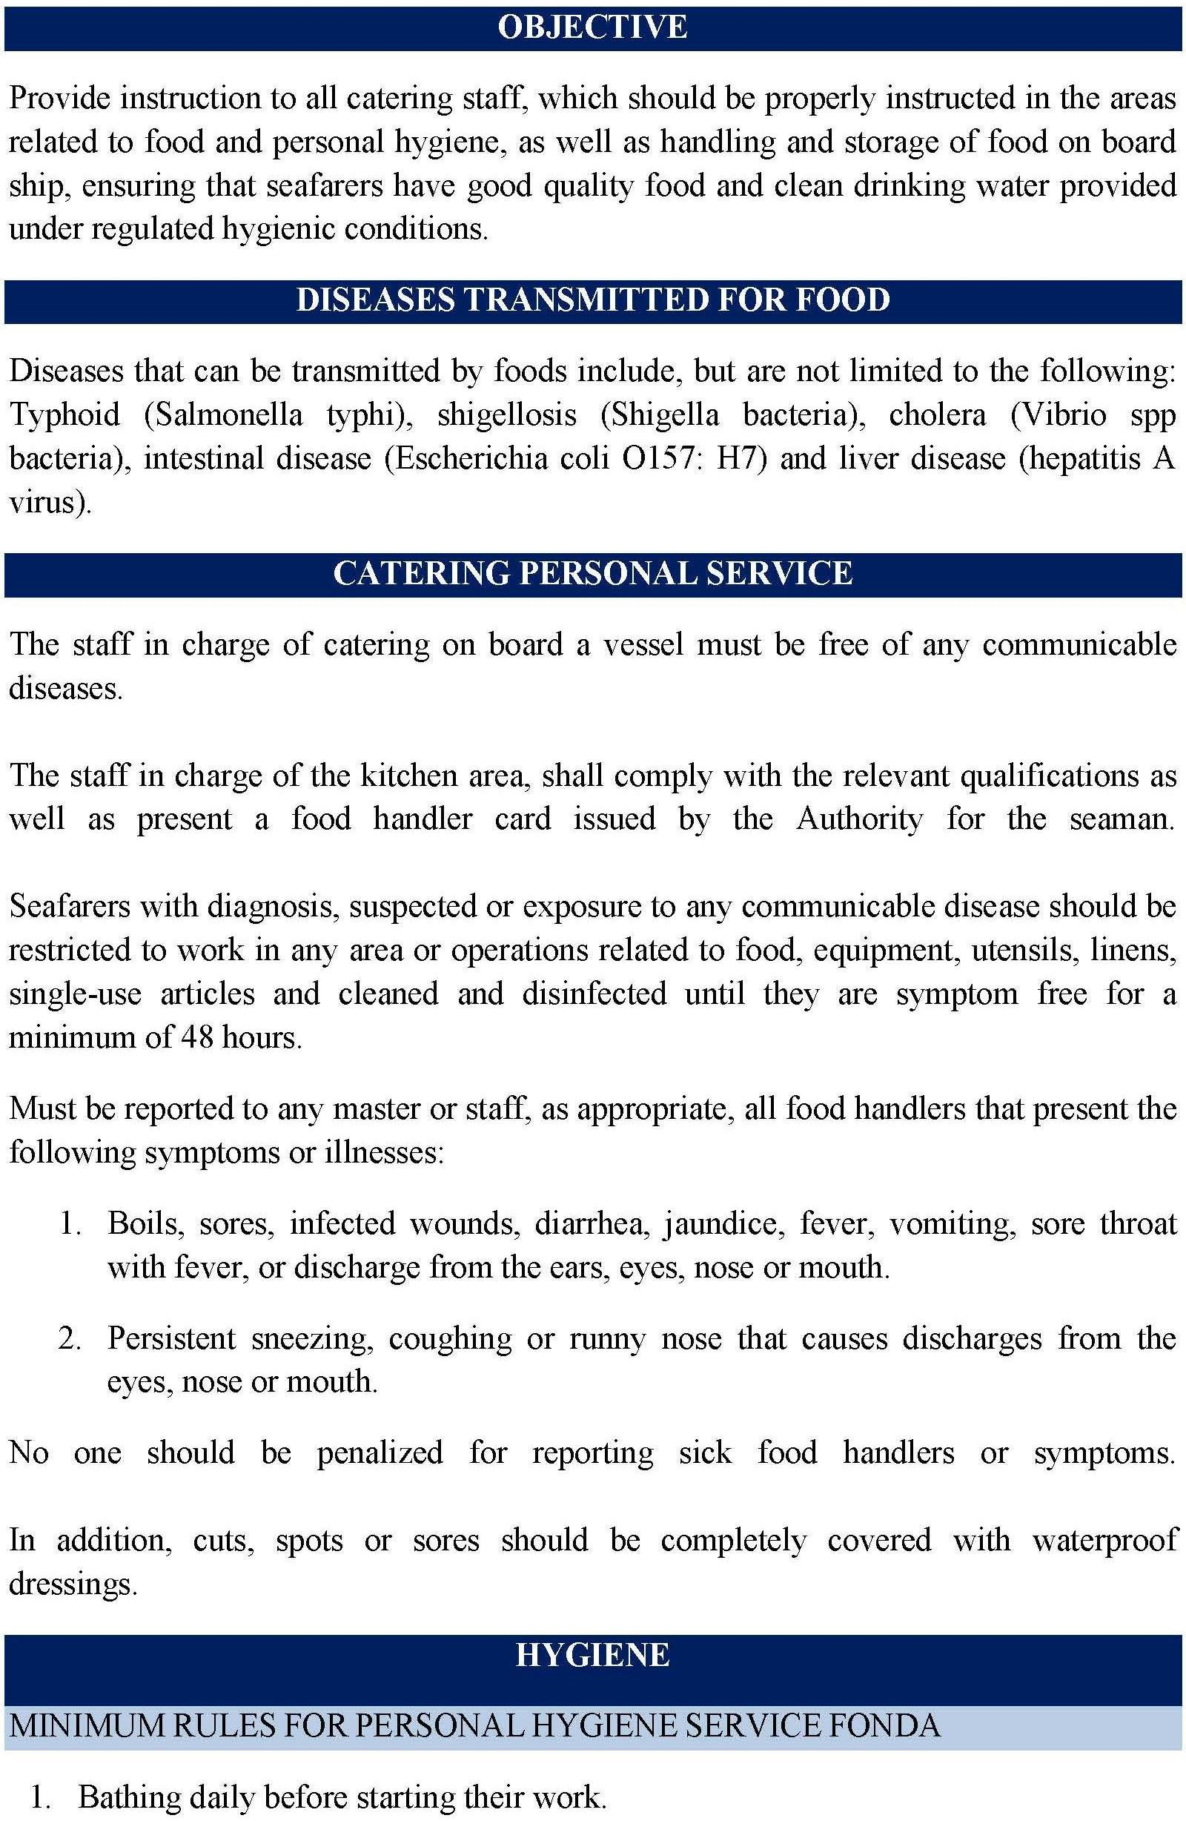

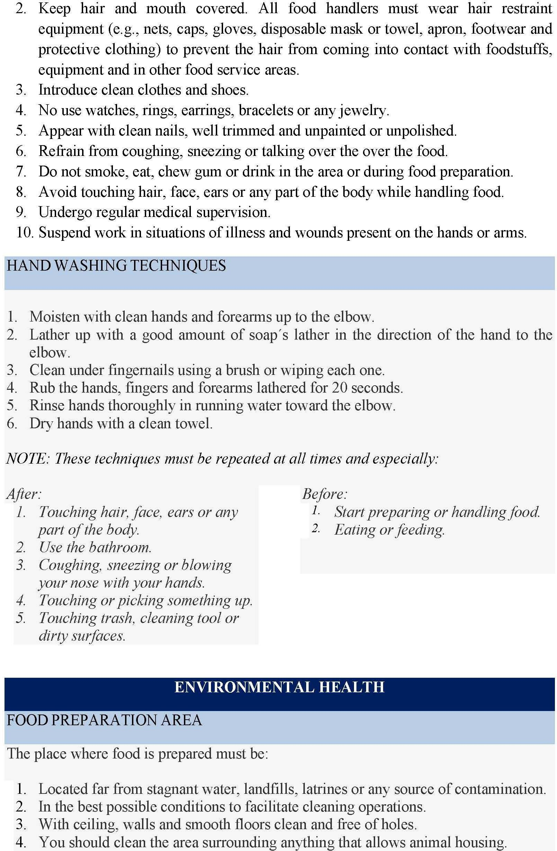

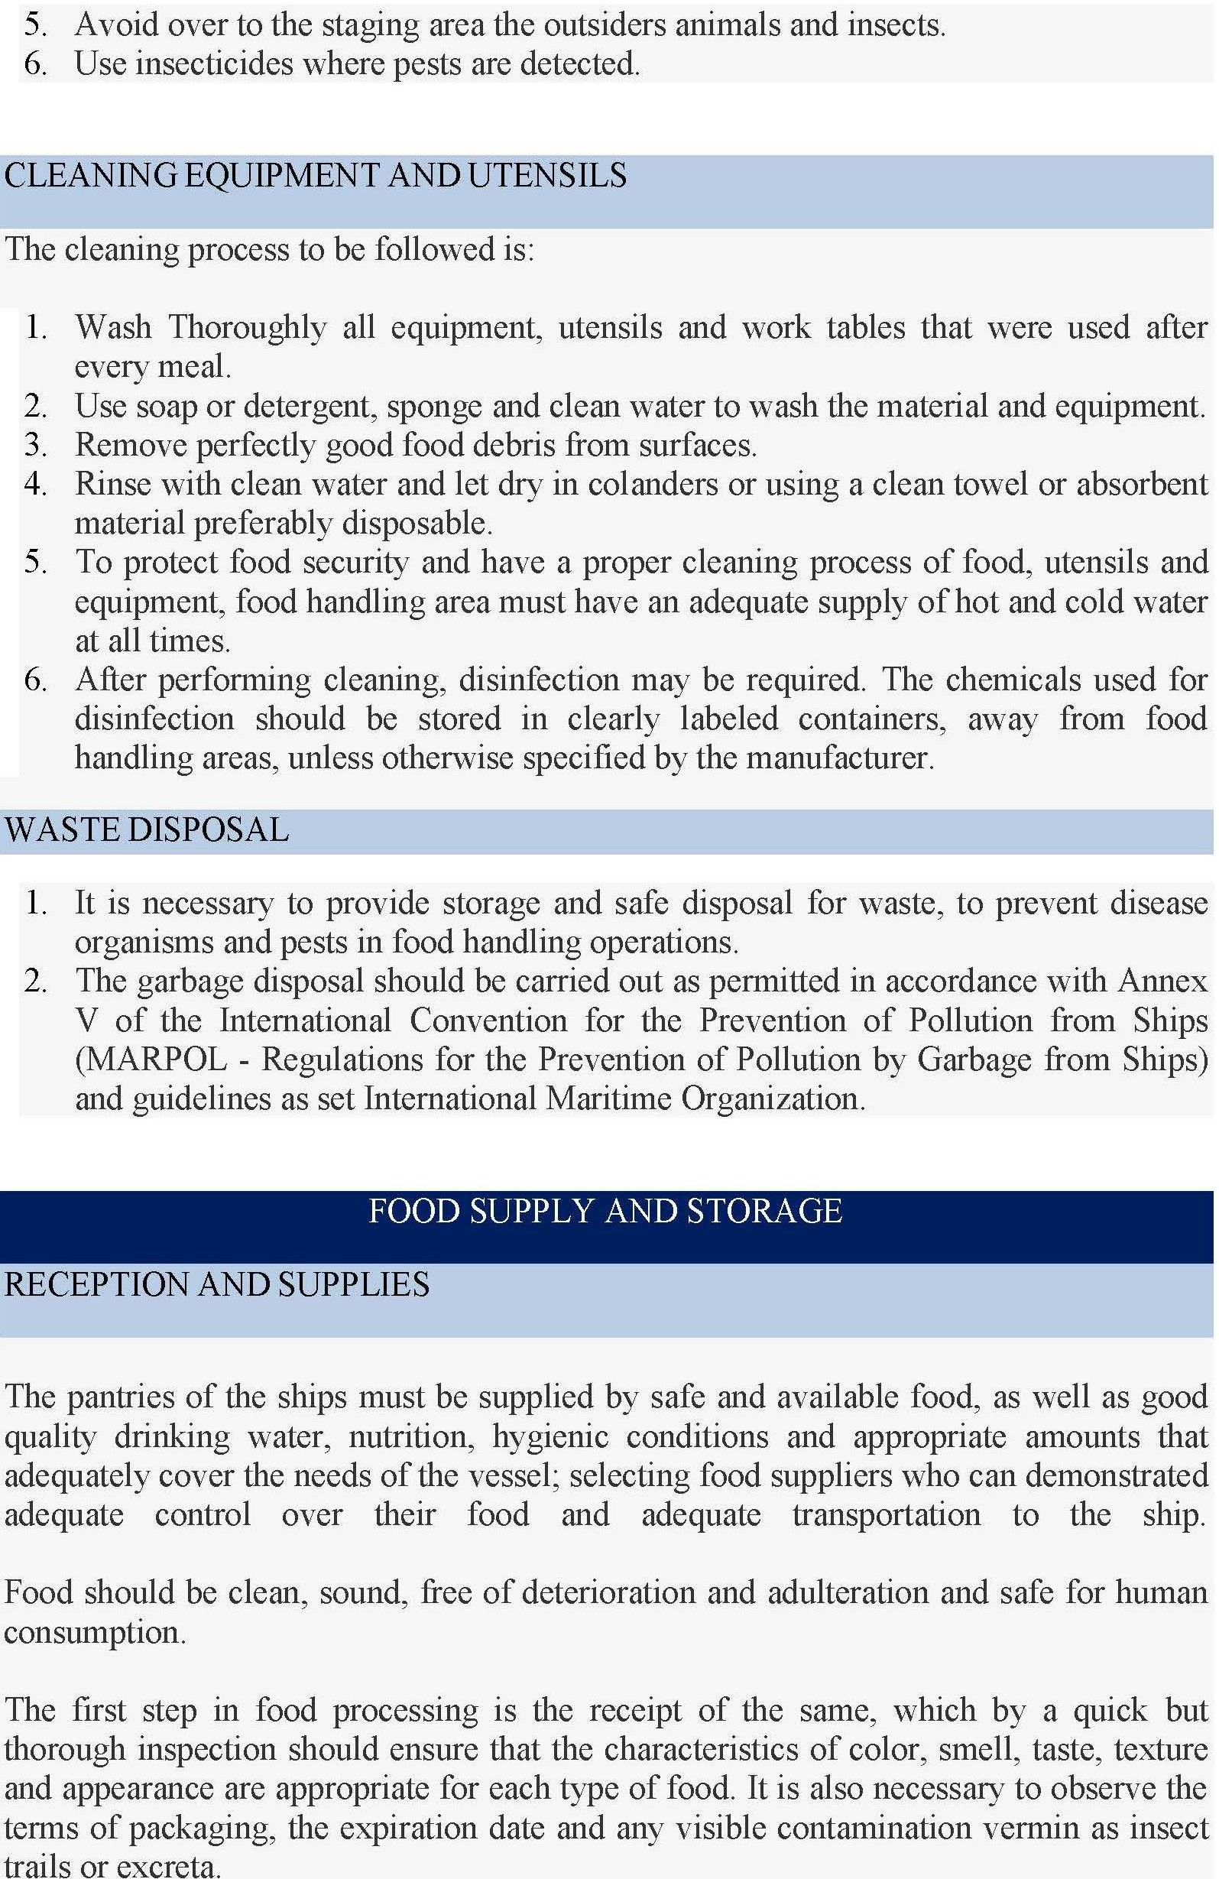

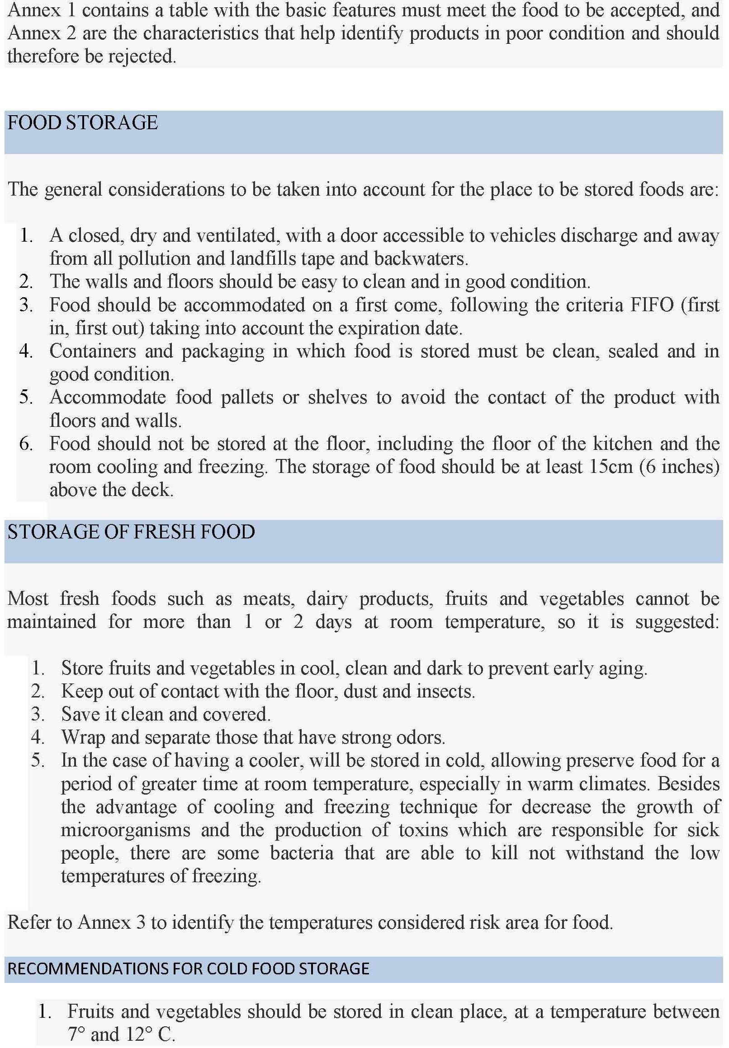

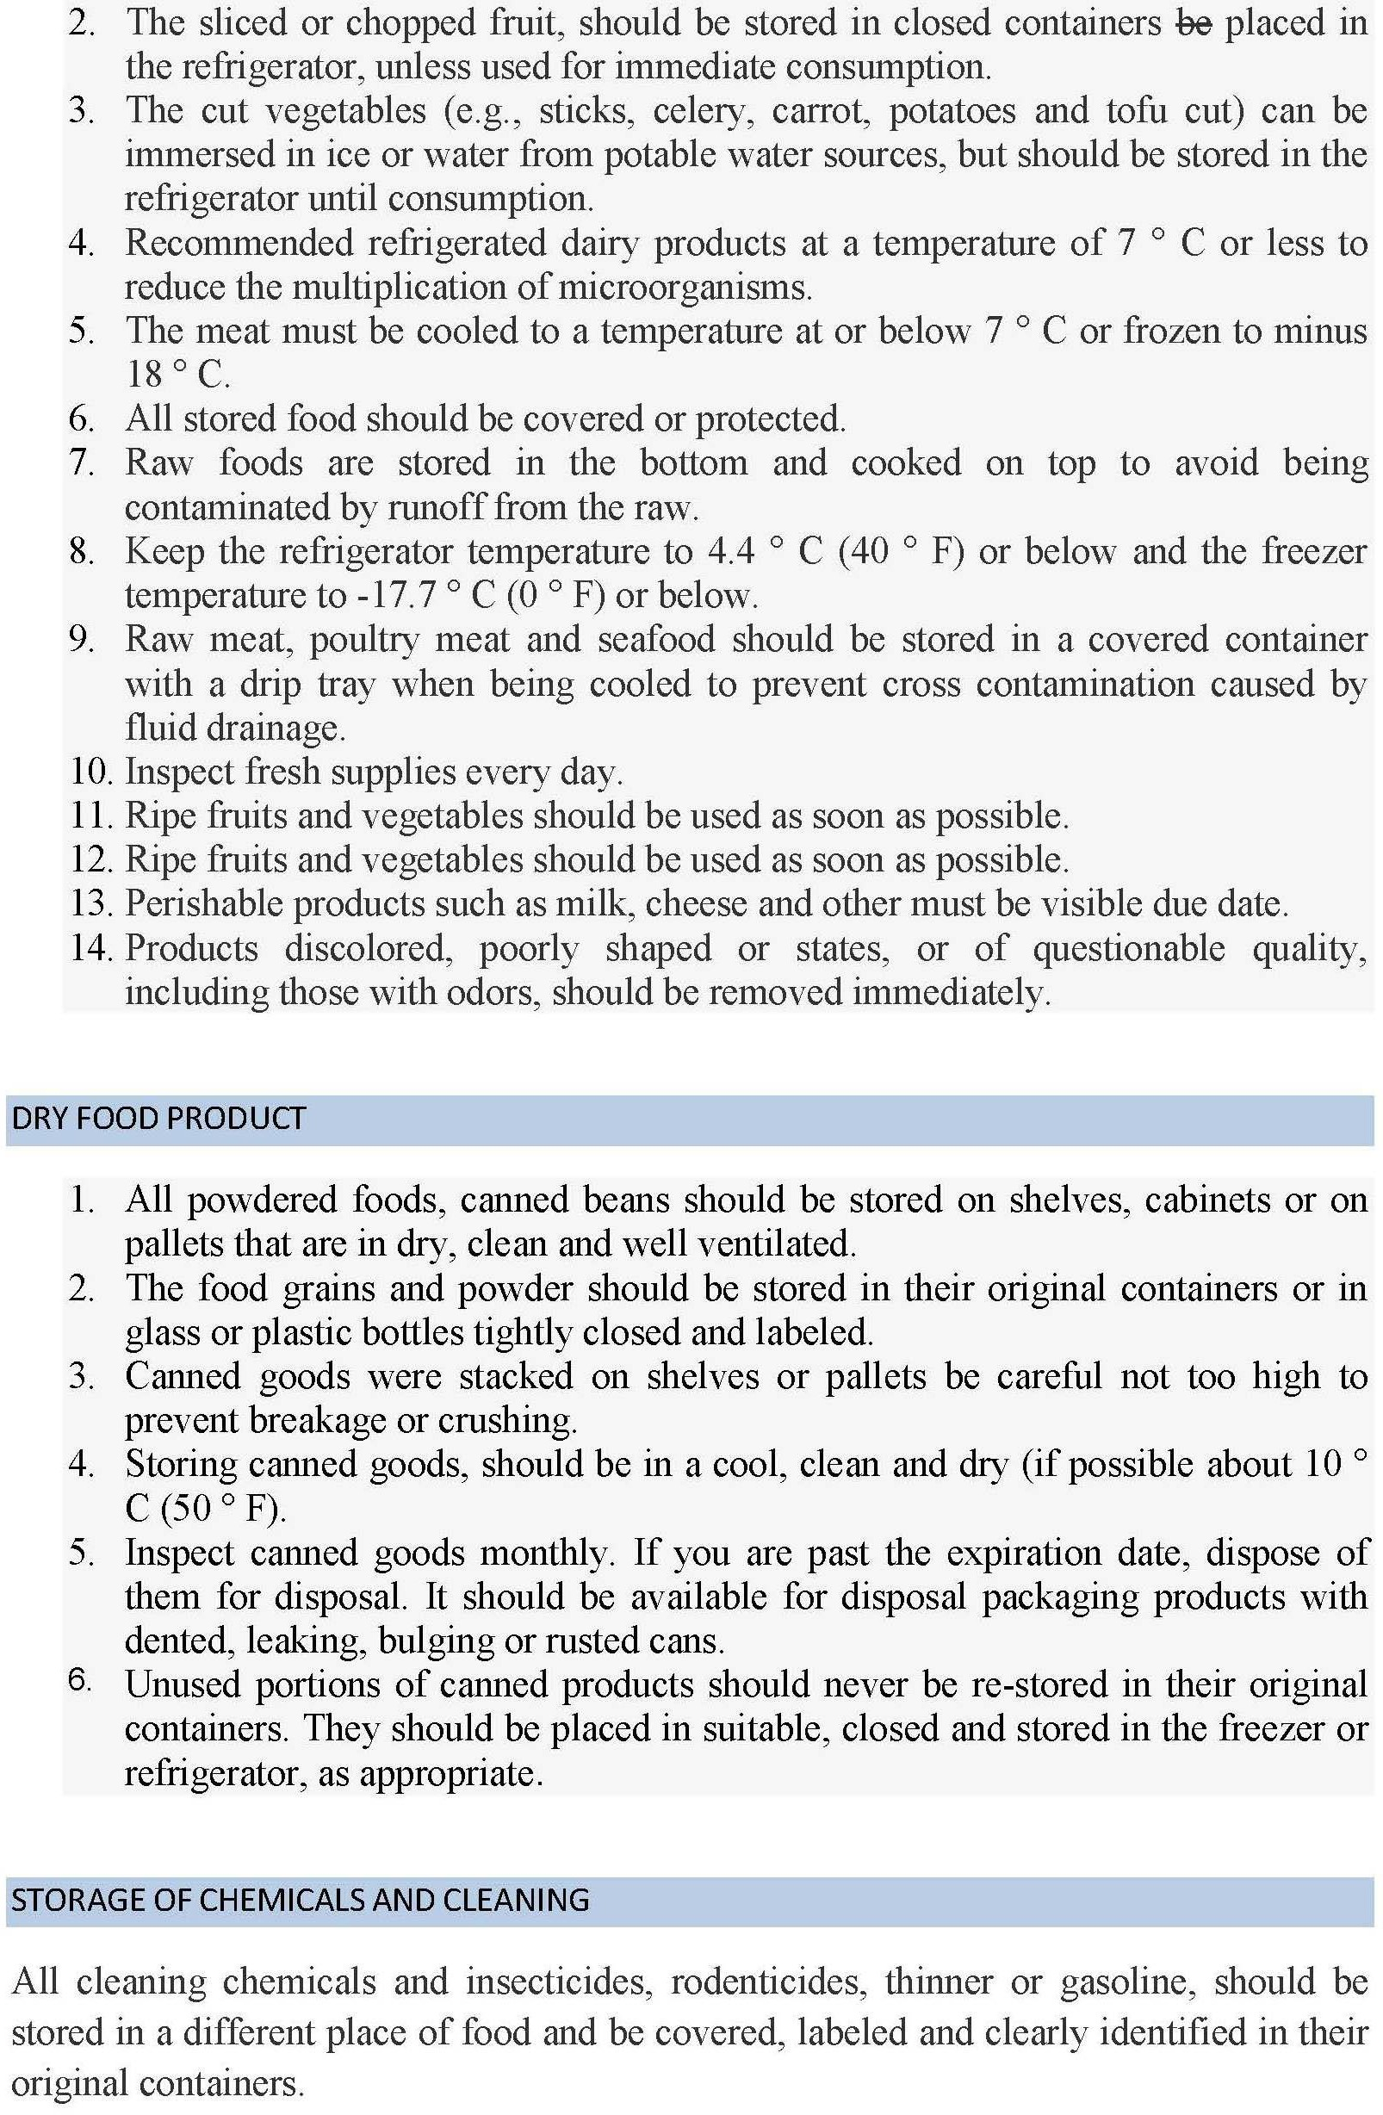

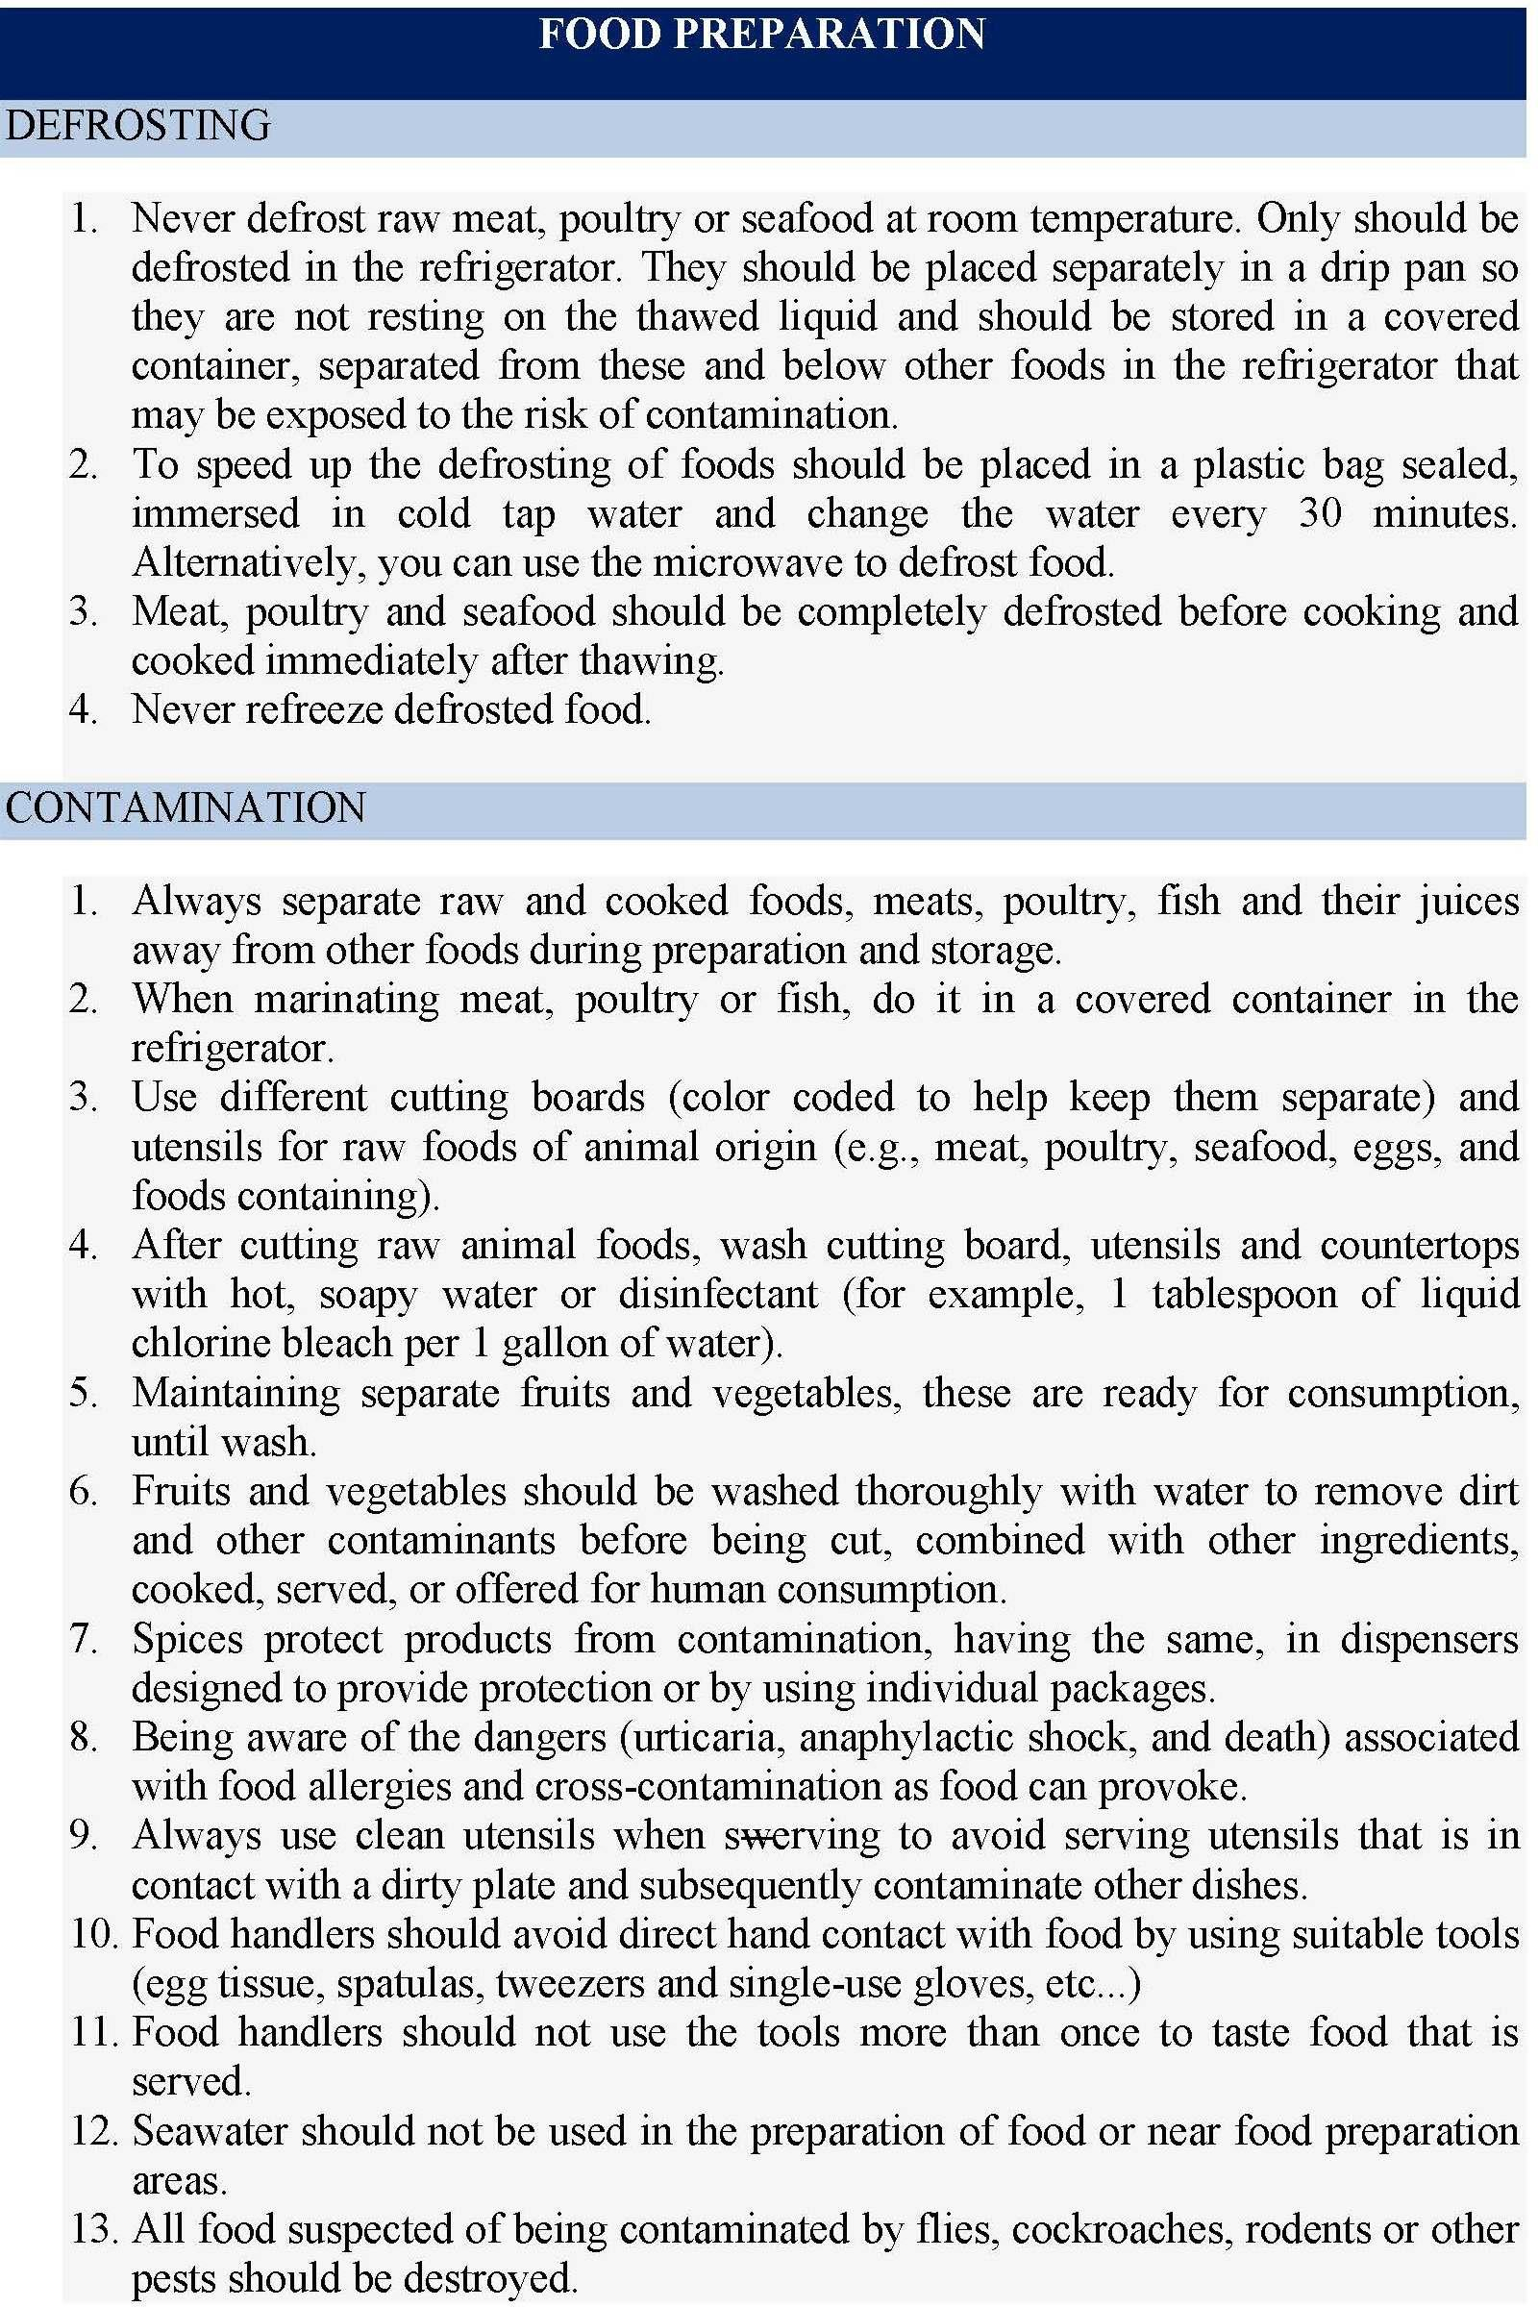

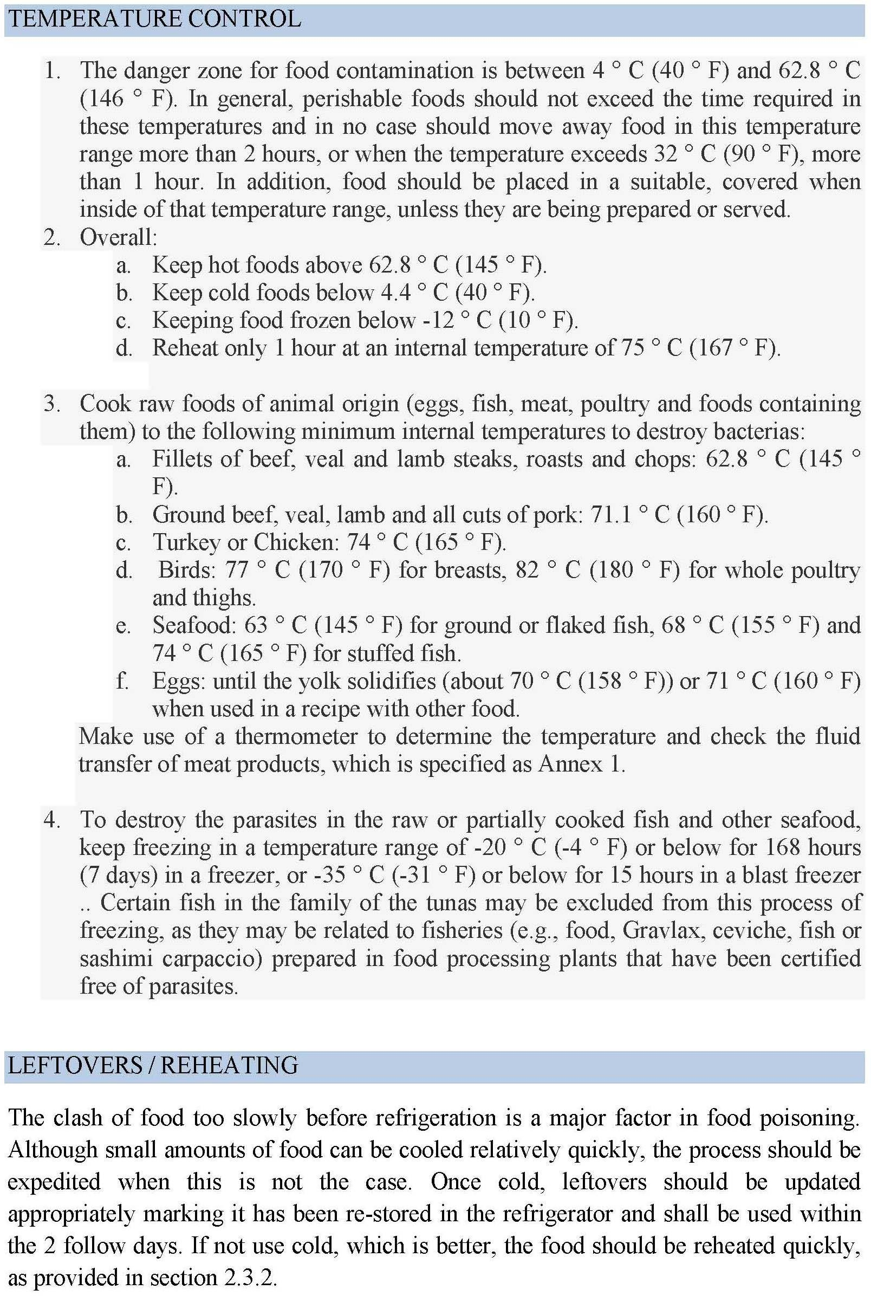

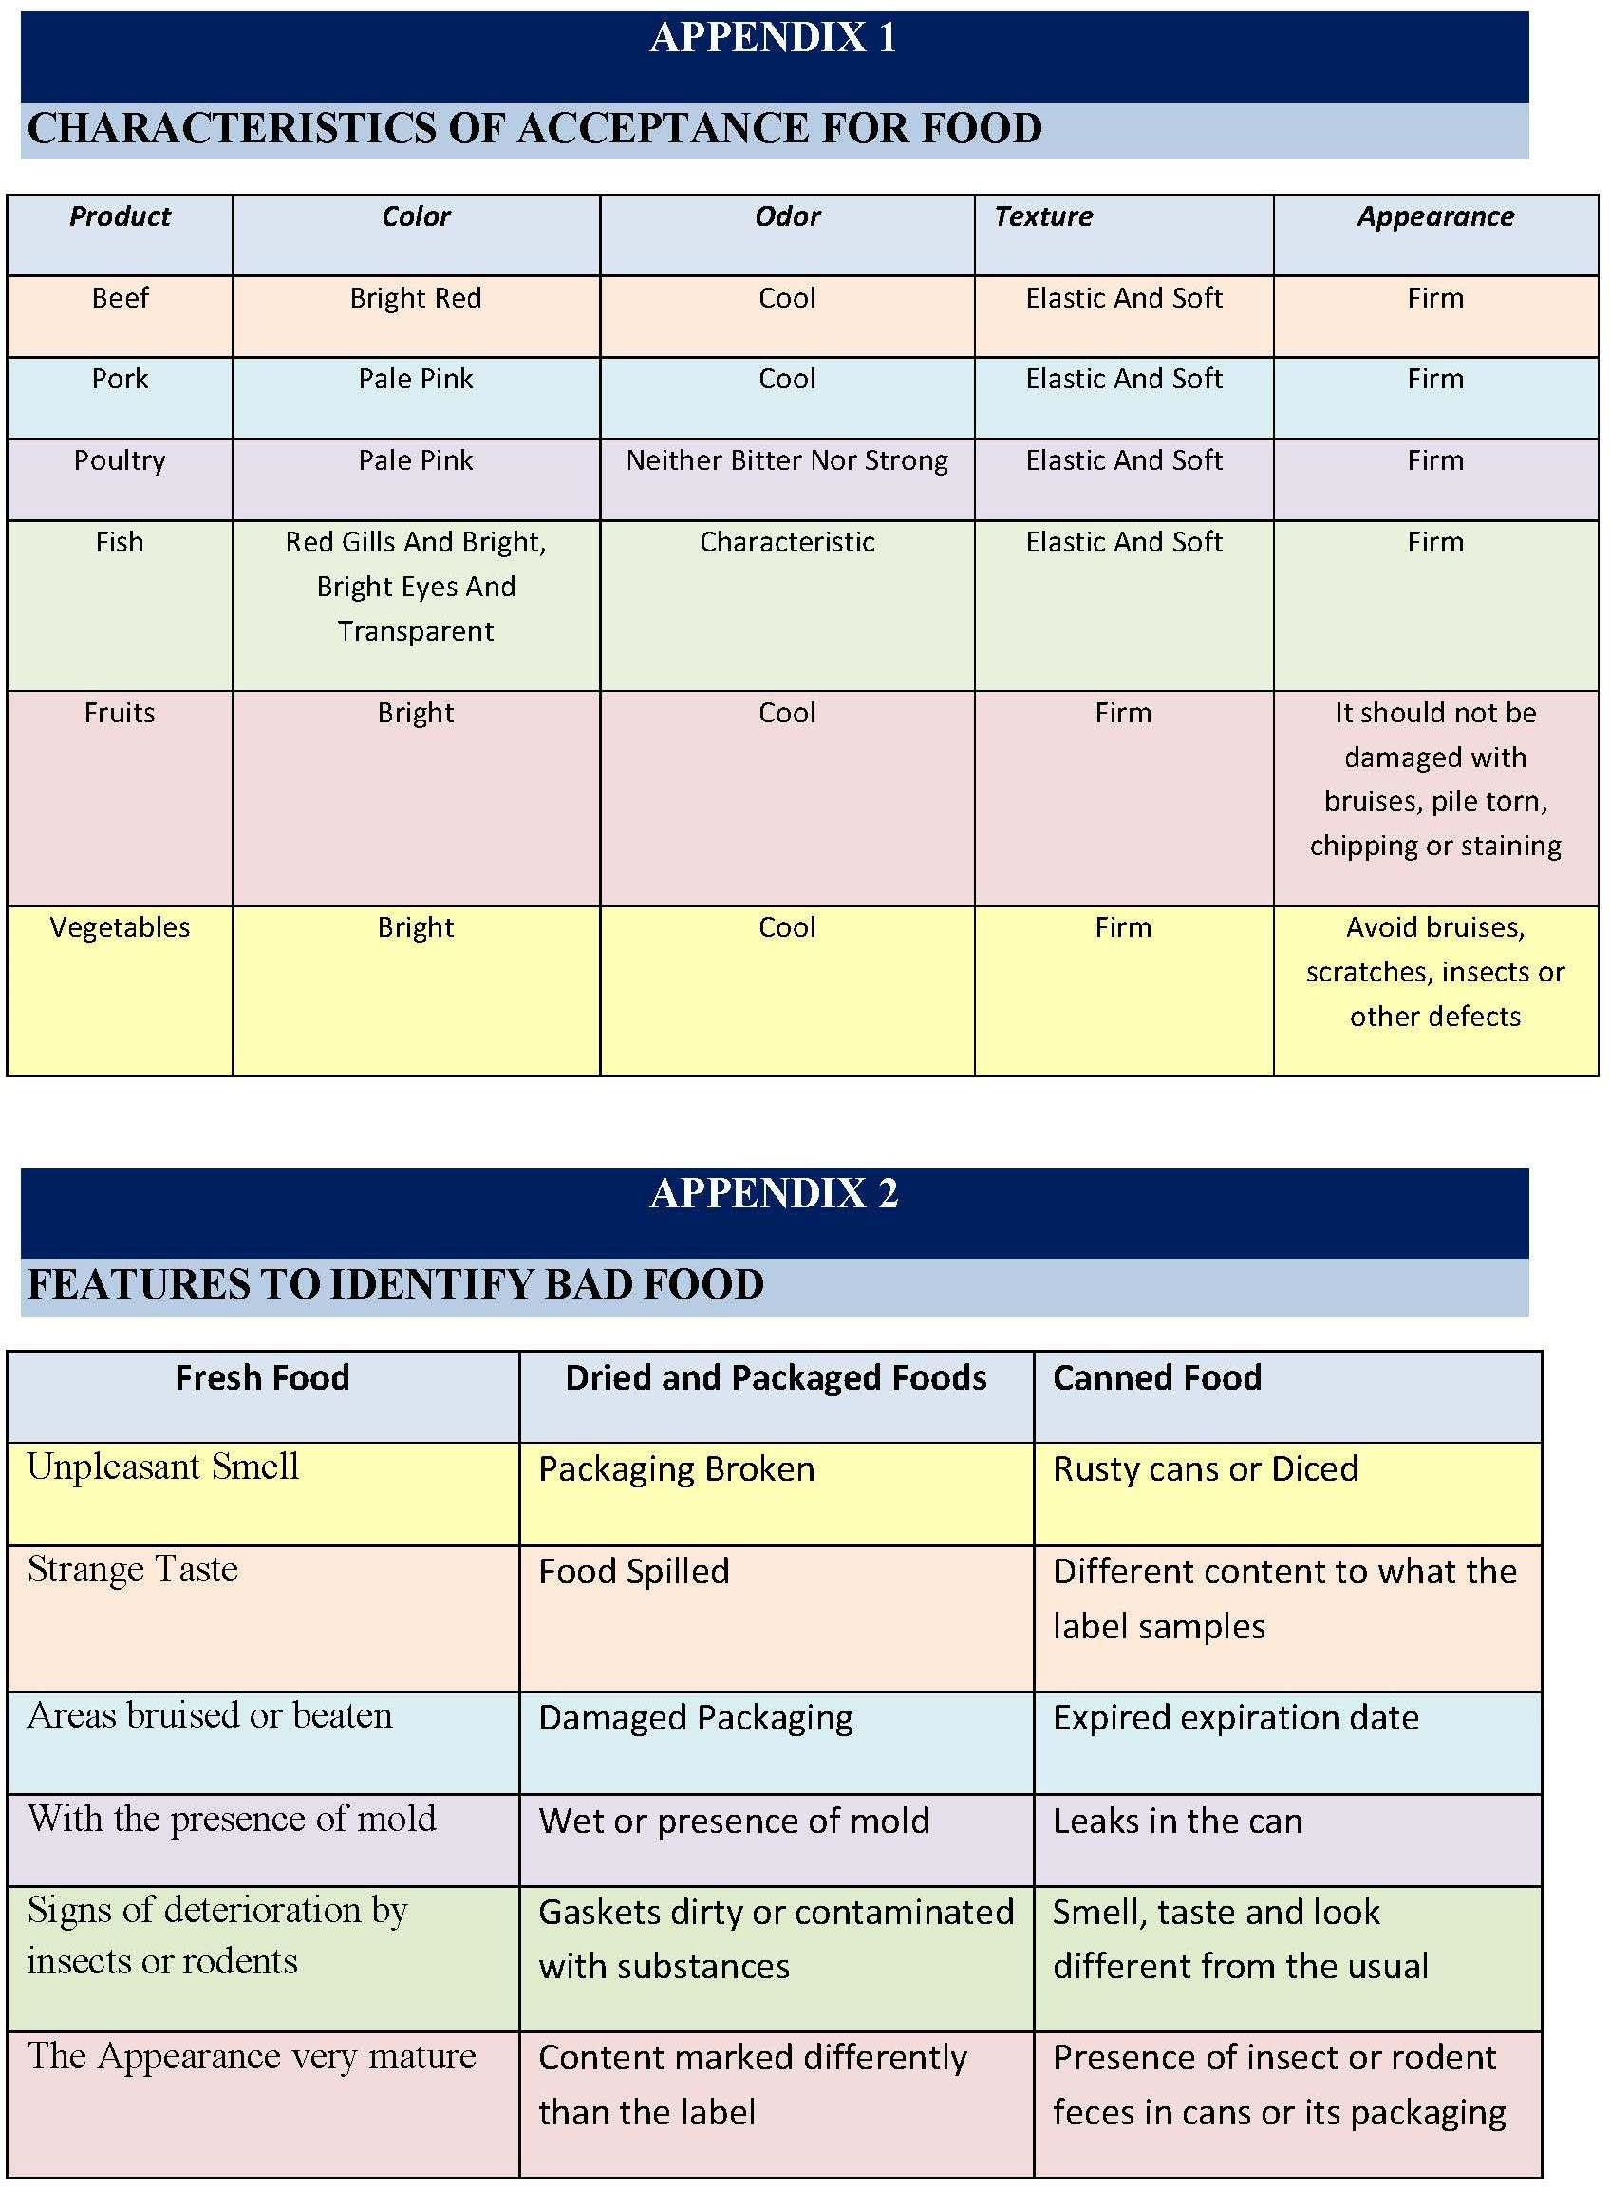

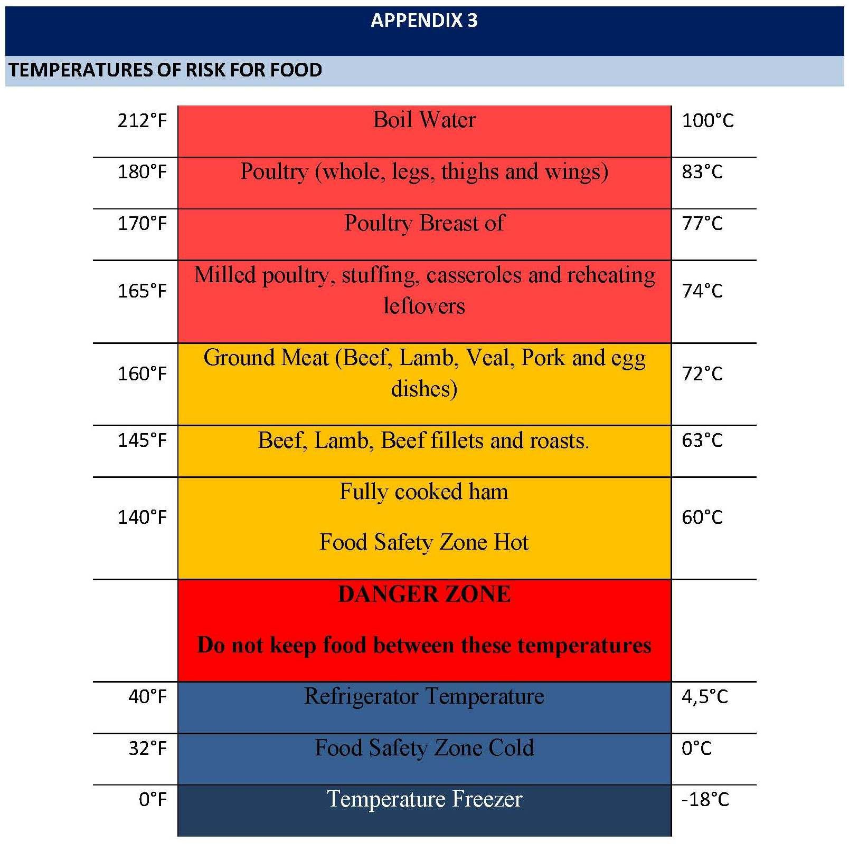

Ship’s cook

Company ensures that seafarers hired as cooks on board a ship, are trained for that purpose and have the qualifications and competences required for such position, for which completion of the training course acknowledge by the Panama Maritime Authority is required and must cover practical cookery, food and personal hygiene, food storage, stock control, environmental protection and catering health and safety.

On ships operating with a prescribed manning of less than ten crew members, may not be required to carry a fully qualified cook, however, anyone processing food in the galley shall be trained or instructed in areas including food and personal hygiene as well as handling and storage of food on board a ship, in accordance to the Administration.

Every seafarer hired as a cook on board a ship, having a license (certificate of competence) at the entry into force of the MLC, 2006 (August 20, 2013) issued by the Panama Maritime Authority but not counting with a training course endorsed by the Panama Maritime Authority certifying him as a fully qualified cook, shall be granted a grace period of one year starting at the entry into force of the MLC, 2006 in order to obtain the training and endorsement accrediting him as a fully qualified cook. During the time in which the seafarer has not yet obtained the certificate described above, he shall follow the guidelines authorized by the Administration, in areas including food and personal hygiene as well as handling and storage of food on board ship.

During the grace period, the persons previously indicated, shall continue performing their usual jobs according to their respective contracts, with the commitment that during the grace period, obtain the approval certificate of the training course for cooks required by the national legislation, which shall be endorsed by the Panama Maritime Authority.

Once the MLC,2006 enters into force, a seafarer shall be considered as qualified to opt for a license (certificate of competence) accrediting him as cook on board a Panamanian flagged vessel, only if the following requirements are met:

- General or Administrative Requirements:

- Application.

- 6 color pictures of 3x3 cm.

- Copy of passport or personal identification number.

- Valid medic certificate, in accordance to Regulation I/9 of the STCW, amended; and Regulation 1.2 of the MLC,2006.
- Proof of having passed the 4 basic courses: a- Personal Survival Techniques
b- Prevention and Fight Against Fire c- Basic First Aid
d- Personal Safety and Social Responsibility

- Specific Requirements for Cooks:

- The applicant must be 18 years old

- The applicant must have completed a training course acknowledged by the Panama Maritime Authority, covering practical cookery, food and personal hygiene, food storage, stock control, environmental protection and catering health and safety.

- The applicant shall endorse the training course acknowledged by the Panama Maritime Authority, covering practical cookery, food and personal hygiene, food storage, stock control, environmental protection and catering health and safety.

*No experience on board is required.

The Panama Maritime Authority in circumstances of exceptional necessity, may issue a dispensation permitting a non-fully qualified cook to serve in a specified ship for a specified limited period, until the next convenient port of call or for a period not exceeding one month, provided that the person to whom the dispensation is issued is trained or instructed in areas including food and personal hygiene as well as handling and storage of food on board ship.

Objectives
MLC-PR-10 MEDICAL CARE

- to protect the health of seafarers and ensure their prompt access to medical care on board ship and ashore;
- to ensure that seafarers are protected from the financial consequences of sickness, injury or death occurring in connection with their employment.

Scope
This procedure applies to all seafarers employed on the vessels managed by the company.

Responsibilities
Master is responsible for implementation of this procedure.

References
- MLC Standard A4.1.2
- WHO International Medical Guide for Ships

Regulations
ILO MLC

Related Forms
- MLC-F-04 Seafarer Injury and Illness Medical Record
- MLC-F-04A Report on Personal Injury
- MLC-F-05 Catering Facilities Hygiene Check-list
- MLC-F-10 Monthly Illness Report
- MLC-F-12 Summary 6th Months Illness Report
- Safety Management System. C/L: A24 Medical Attention Request

Procedure Content
    - Medical Care Onboard
It is company’s policy that seafarers are given health protection and medical care including prompt access to the necessary medicines, medical equipment and facilities for diagnosis and treatment and to medical information and expertise.

The Master in coordination with the Chief Officer are responsible to ensure in regular intervals not exceeding twelve (12), that the medicine chest inventory is up to date and maintained as per the “International Medical Guide for Ships”, as well as that the expired medicines are promptly replaced and incinerated onboard.

The Chief Officer is the Medical Officer onboard and is in charge of the medical care and capable of administering same, as well as medicine and also medical first-aid, being certified and having completed training in medical care and medical first aid as per the requirements of STCW, including refresh courses as found necessary.

The medical form MLC-F-04 Seafarer Injury and Illness Medical Record shall be completed by the Master and the Chief Officer (Medical Officer) when a crew member needs medical treatment and its contents must be kept confidential and must only be used to facilitate the treatment of seafarers. The form is kept in the separate file “MLC Documents”, in the Master’s office.

All company’s vessels are equipped with a separate hospital accommodation which is used exclusively for medical purposes.

Furthermore, seafarers working onboard company’s vessels have the right to visit a qualified medical doctor or dentist without delay when in port, where practicable.

The medical care and health protection services for seafarers who are serving onboard company’s vessels or landed in a foreign port are provided free of charge to seafarers.

In addition, all company’s vessels carry out updated list of coast earth stations and radio stations through which medical advice service can be obtained on a 24-hrs basis.

Finally, the company has established procedures (i.e. publications, risk assessment, circulars, standing instructions, notices/signboards, etc) in order to ensure that measures providing for health protection and medical care are not limited only to treatment, but also to prevention of injury or, as far as practicable, sickness.

Shipowner Liability

- The Company is responsible for health protection and medical care of all seafarers working on board the ships in accordance with the following standards:

- bear the costs for seafarers working on Company’s ships in respect of sickness and injury of the seafarers occurring between the date of commencing duty and the date upon which they are deemed duly repatriated, or arising from their employment between those dates;

- provide financial security to assure compensation in the event of the death or long-term disability of seafarers due to an occupational injury, illness or hazard, as set out in national law, the seafarers' employment agreement or collective agreement;

- defray the expense of medical care, including medical treatment and the supply of the necessary medicines and therapeutic appliances, and board and lodging away from home until the sick or injured seafarer has recovered, or until the sickness or incapacity has been declared of a permanent character; and

- pay the cost of burial expenses in the case of death occurring on board or ashore during the period of engagement.

National laws or regulations may limit the liability of the Company to defray the expense of medical care and board and lodging to a period which shall not be less than 16 weeks from the day of the injury or the commencement of the sickness.

- Where the sickness or injury results in incapacity for work the Company is liable:

- to pay full wages as long as the sick or injured seafarers remain on board or until the seafarers have been repatriated in accordance with this Convention; and

- to pay wages in whole or in part as prescribed by national laws or regulations or as provided for in collective agreements from the time when the seafarers are repatriated or landed until their recovery.

National laws or regulations may limit the liability of the Company to pay wages in whole or in part in respect of a seafarer no longer on board to a period which shall not be less than 16 weeks from the day of the injury or the commencement of the sickness.

- National laws or regulations may exclude the Company from liability in respect of:

- injury incurred otherwise than in the service of the ship;

- injury or sickness due to the wilful misconduct of the sick, injured or deceased seafarer; and

- sickness or infirmity intentionally concealed when the engagement is entered into.

- National laws or regulations may exempt the Company from liability to defray the expense of medical care and board and lodging and burial expenses in so far as such liability is assumed by the public authorities.

- The Company protects property left on board by sick, injured or deceased seafarers and returns it to them or to their next of kin by following procedure implemented onboard all Company’s vessels:

The Master or Chief Officer together with Bosun or an AB and two other crew members, as witnesses, conduct an inventory of the belongings left onboard by the sick, injured or deceased crew the document of which is duly signed by all. The original copy of the inventory document is packed safely together with the crew’s belongings ready for despatch. A copy of the inventory is sent to the Company. The package with belongings is despatched to the sick, injured or deceased crew’s home either borne by a compatriot repatriating crew, who may volunteer to do that, or by airfreight or courier service from the next convenient port – taking into consideration customs restrictions and/or security matters in certain ports. All expenses relevant to such despatch (airfreight or courier service cost, overweight charge, etc.) are borne by the Company.

Objectives
MLC-PR-11 DRUGS & ALCOHOL

- to provide a safe, healthy and productive working environment and that the safety of ship, personnel and cargo shall not be impaired or compromised by the use of drugs or alcohol.

Scope
This procedure applies to all seafarers employed on the vessels managed by the company.

Responsibilities
Master is responsible for implementation of this procedure.

References
- Safety Management System Procedure Drug & Alcohol Policy
- Procedure to enforce the drug and alcohol policy

Regulations
- ILO MLC
- ISM Code
- MQS-Sec 2.2

Related Forms
- MQS-Sec 2.2 C/L. No. A3 – Drug and alcohol (D&A) reporting form
- MQS-Sec 2.2 C/L. No. A3 (a) – Drug and alcohol chain custody

Procedure Content
The possession, consumption or sale of illegal drugs or any alcohol based products, is prohibited at all times, the blood alcohol content is to be 0.0%.

Any employee who is taking a prescription drug for medical purposes is required to present a statement from the prescribing physician that the prescription drug will not impair the employee's work performance.

All seafarers will be tested prior to joining for the presence of controlled substances (like marijuana, cocaine, opiates, amphetamines, phencyclidine (PCP) and alcohol) and will be subject to reasonable cause, periodic, random, and post accident drug testing.

In the interest of the safety and health of it's employees, Company reserves the right to inspect and search, at random, unannounced times, any personal belongings of any person on board company vessels.

Company will conduct random unannounced tests onboard all its owned or managed tanker vessels by use of a contracting laboratory at least annually. Company will conduct random unannounced alcohol tests at least quarterly.

The Company policy applies to all employees and includes all crew, company staff, sub-contractor or any other person working on or attending the vessel. No person is allowed to bring alcohol onboard at any time. The Limits as prescribed in the company Drug and Alcohol Policy must be strictly observed. Each vessel is supplied with a breath-testing meter that will be used to indicate the amount of alcohol in exhaled breath (the breathalyzer). All Masters and Senior Officers must be familiar with its use.

Random Testing by external contractor: The Company contracts random testing for each tanker by an external company at least once per year. Drug and Alcohol testing is administered by the onboard collection and testing ashore of urine and/or blood samples. To ensure the correct legal recording and security of samples during collection and testing, an approved drug testing company is used and a trained shore based collector will administer the collection. The contractor will board the vessel with a list of names supplied by the Personnel Department. The names are chosen at random within the office and will usually number about one third to one half of the ship's personnel. As names are chosen at random the same person may be tested on more than one occasion in his / her tour of duty. Masters are to ensure the prompt attendance of all crewmembers as listed by the collector. Collection is performed individually and privately and samples are immediately labelled and registered. A Senior Officer should be present to assist with the administration of the collection. Masters are to be guided by the collector for the actual requirements onboard. Results are notified to the vessel as soon as they are received in the office. Masters should allow two weeks before test results are known. A positive test will be grounds for dismissal from the vessel as evidencing a breach of the code of conduct.

ONBOARD ALCOHOL TESTING

In addition, unannounced onboard alcohol tests are to be done by the Master upon in- struction from the Company Personnel Department once each quarter. If the Master is required to be tested, either the Chief Engineer or Chief Officer will carry this out. Onboard alcohol tests carried out onboard are to be recorded and reported in writing within 2 (two) hours to the Personnel Department confirming that the test has been carried out and advise of any positive results (including any refusal to test). SMS Form

Onboard Drug and Alcohol Test is to be sent with the monthly mail.

Testing in Case of Reasonable Cause: Company will require any crewmember who is reasonably suspected of using drugs and/or alcohol to be tested either by means of on board equipment or by a shore based facility. The Master, a Senior Officer, or a member of Company Management Team will instigate onboard breath testing, if there are grounds to believe that a seafarer may be under the influence of alcohol Post accident: Any employee (not necessarily a crewmember) who is directly involved in a serious incident is liable to be tested for drugs and alcohol. Post accident testing applies to all serious marine incidents

Conduct of onboard Test

Masters should ensure the fairness of the testing as follows: The Master is to conduct the testing in the presence of another Senior Officer. The Bosun should also be present for the testing of any Rating - no other personnel should normally be present. The procedure should be carefully explained to the seafarer including the method of operation of the breathalyzer and the measurement of the alcohol content. The seafarer should, if possible, indicate that he understands the procedure. After testing, the readings should be explained to the seafarer

Positive Tests

If a seafarer tests positive then it is recommended that the Master re-tests some 10 minutes after the first test. Confirmed positive breath tests are grounds for disciplinary action by the Master and/or Company Management.

Drugs

Any Master, Officer or Rating found to be in possession of an illegal substance is liable to summary dismissal from the vessel and is liable to pay for the costs of his repatriation and for the travel costs of his relief as well as any fines against the vessel, the Master or the Company. The management of Company, onboard and ashore, will cooperate fully with the authorities during the course of any investigations into the illegal use of drugs.

Testing for Drugs

Drug testing is carried out by laboratory analysis of blood or urine samples by a competent authority or company and under strict controls, which ensure fairness and accuracy. Testing is performed on blood samples supplied at pre-joining medicals. The Company contracts testing of each ship at least annually.

Prescription Drugs

The Master / shipboard management must be informed by any seafarer if the latter is taking any prescription drug for medical purposes. Similarly, such prescriptive drugs must have been declared during the pre-joining medical taken by the seafarer. Where there is any doubt, at the medical or onboard, as to the fitness of the seafarer whilst taking medication, then the Company will seek specialist advice.

Responsibilities

Every individual onboard is responsible for his own compliance with this policy. Disciplinary action will be taken against all persons not complying with the policy. Any observation of non-compliance with the policy is immediately to be reported to the Master. Not reporting such an observation is a severe breach of conduct, and will be treated as non-compliance with this policy and disciplinary action

will be taken.

Local Requirements

Special requirements or circumstances from Charterers, Flag, or Port state authorities (for USA see below) may apply in addition to the Company policy. The Master shall procure relevant information by all possible means and inform the Company accordingly, if such requirements apply to his vessel.

The consumption of alcohol is not permitted onboard the vessel for the entire period that the vessel remains within USA waters or jurisdiction. All supplies of alcohol must be collected under bond until the vessel has cleared USA territorial waters. Visitors may be offered non-alcoholic beverages only. A person (not necessarily a crewmember) who is directly involved in a serious marine incident must be tested for drugs and alcohol. Post-accident testing applies to all serious marine incidents involving commercial vessels regardless of flag of origin. More specifically, this includes crewmembers aboard foreign flag vessels who are directly involved in serious marine incidents occurring in U.S. waters.

MLC-PR-12 HEALTH & SAFETY PROTECTION AND ACCIDENT PREVENTION

Objectives
- to provide a safe, healthy and productive working environment and that the safety of ship, personnel and cargo shall not be impaired or compromised by the use of drugs or alcohol.

Scope
This procedure applies to all seafarers employed on the vessels managed by the company.

Responsibilities
Master is responsible for implementation of this procedure.

References
- ILO MLC, Reg.4.3
- ISM Code
- Safety Management System. Section 3. Operations Safety
- Safety Management System. Section 4. Health, hygiene & Housekeeping.
- Safety Management System. Section 11. Risk Management & Job Safety Analysis
- MN MLC Circulars of PMA.

Regulations
- ILO MLC
- ISM Code

Related Forms
- SMS. Section 3. Operations Safety
- SMS. Section 4. Health, hygiene & Housekeeping.
- SMS. Section 11. Risk Management & Job Safety Analysis
- SMS. C/L: A33(d). Statistic of Personal Accident.
- SMS. C/L: B16. Personal Accident Report
- SMS. C/L: B23. Job Safety Analysis Form.
- SMS. C/L: B29. Occupational Health & Safety Inspection Record
- SMS. C/L: B42. Near Miss Report
- MLC-F-04A. Report of Personal Injury.

Procedure Content
The company has established procedures (i.e. publications, risk assessment, circulars, standing instructions, notices/signboards, etc) for preventing occupational accidents and injuries on ships including measures to reduce and prevent the risk of exposure to harmful levels of ambient factors and chemicals as well as the risk of injury or disease that may arise from the use of equipment and machinery onboard not limited only to treatment, but also to prevention of injury.

Risk assessment for health, safety and accident prevention and diseases is carried out as per the procedure and guidelines of the company’s Risk Assessment manual, in consideration of the company’s Safety Management System, also.

Furthermore, adequate safety procedures and instructions are in place for the following:
- General and basic provisions;
- Guarding of vessel’s equipment and machinery including required maintenance;
- Structural features of the ship;
- Means of access onboard;
- Handling of anchors, chains and mooring lines;
- Handling of cargo, lashing equipment;
- Safe operation of external and internal ramps;
- Fire prevention and fire fighting;
- Use of proper personal protective equipment;
- Working on deck and machinery spaces;
- Work in enclosed / dangerous spaces;
- Commencement of hot works;
- Asbestos-free materials use onboard;
- Prevention of fatigue;
- Prevention of disease;
- HIV/AIDS protection and prevention;
- The effects of drug and alcohol abuse;
- Responding to accidents and emergencies;

A permit-to-work system is in place in order to ensure that all relevant safety precautions are kept prior to commence hot works onboard, and/or prior to enter an enclosed or dangerous space and /or any other work to machinery or equipment that might be carried out.

Moreover, the company’s vessels are equipped with hand / face washing stations in the accommodation and in the Engine room and an eye-washing station, also.

Upon joining the ship and prior commencing any works, the seafarer receives a personal safety training including briefing on the onboard emergency procedures.

Thereafter, a structured training program is implemented to train the crew in safe working practices and increase their awareness of hazards at the work place

A safety committee is formed onboard monthly in order to effectively address health and safety matters.

The Master in co-ordination with the Chief Officer (Safety Officer) is responsible for the implementation of and compliance with the ship’s occupational safety and health policy and programs.

In the Safety meetings also participate at least, the 2nd Officer, the Chief Engineer, the 2nd Engineer, the Electrician and the Bosun, as well as any other appointed crew member.

Minutes of these meetings are recorded in form “Safety Committee Meeting” and kept onboard, while a copy is sent to the DPA.

All accidents and near-misses onboard are investigated and reported to the DPA and TSI, who review and evaluate the reports and decide if further corrective/preventive action is required.

Reference is made to the company’s Procedures.

In connection to the above procedure, any such near-misses, hazardous occurrences and accidents are submitted from each fleet vessel.

Any lessons learnt from the accident and near-miss reports, are circulated to the fleet as appropriate.

During the annual Management Review, the company conducts an annual review and analysis of any accidents and of the hazardous occurrences reported by the fleet and the results are communicated to the fleet.

MLC-PR-13 ENTITLEMENT TO LEAVE & LOSS OF SHIP OR FOUNDERING COMPENSATION

Objectives
- to ensure that seafarers have adequate leave;
- to ensure that seafarers are compensated when a ship is lost or has foundered.

Scope
This procedure applies to all seafarers employed on the vessels managed by the company.

Responsibilities
Company is responsible for implementation of this procedure.

References
ILO MLC SEA

Regulations
ILO MLC SEA

Related Forms
None

Procedure Content

    - Entitlement to Leave

Whenever and wherever possible, all crew are granted shore leave to benefit their health and wellbeing and with the operational requirements of their positions.

All crew receive annual leave with pay calculated on the basis of a minimum of 2.5 calendar days per month of employment. Justified absences from work are not considered as annual leave.

Any absence from work to attend an approved maritime vocational training course or for such reasons as illness or injury or for maternity are counted as part of the period of service. The following are not counted as part of annual leave with pay:

- public and customary holidays recognized by the Flag Administration whether or not these fall during the annual leave with pay;
- periods of incapacity for work resulting from illness or injury or from maternity;
- temporary shore leave granted to a seafarer while under an employment agreement;
- compensatory leave of any kind.

A seafarer taking annual leave should be recalled only in cases of extreme emergency and with the seafarer’s consent.

The level of pay during annual leave should be at the seafarer’s normal level of pay provided for in the applicable SEA. Where the employment period is less than one year or in the event of termination of employment, entitlement to pay should be calculated on a pro-rata basis.

Loss of Ship or Foundering Compensation

The Company provides for compensation to each seafarer in the case of unemployment arising from the ship’s loss or foundering, which is paid for the days during which the seafarer remains in fact unemployed at the same rate as the wages payable under the employment agreement but the total compensation payable to any one seafarer maybe limited to two (2) months wages or as agreed in any applicable SEA.

Objectives
MLC-PR-14 SEAFARER REPATRIATION

- to ensure that seafarers are able to return home

Scope
This procedure applies to all seafarers employed on the vessels managed by the company.

Responsibilities
Company is responsible for implementation of this procedure.

References
- SMS
- Company SEA

Regulations
ILO MLC, Reg. 2.1.

Related Forms
None

Procedure Content

The Company maintains financial security to ensure that crew are duly repatriated.
No crew is required to serve on board a ship for a period of 12 months or more, before being entitled to repatriation.
Crew are entitled to repatriation at no cost to themselves subject to the following conditions:
- if the seafarers’ employment agreement expires while they are abroad;
- in the following cases where the seafarer employment agreement is terminated:
  - in the event of illness or injury or other medical condition which requires their repatriation when found medically fit to travel;
  - in the event of shipwreck;
  - in the event of the Company not being able to continue to fulfil their legal or contractual obligations as an employer of the seafarers by reason of insolvency, sale of ship, change of ship’s registration or any other similar reason;
  - in the event of a ship being bound for a war zone, as defined by national laws or regulations or SEA, to which the seafarer does not consent to go;
  - in the event of termination or interruption of employment in accordance with an industrial award or collective agreement, or termination of employment for any other similar reason.

The Company arranges crew repatriation by appropriate and expeditious means. The destinations may include the countries with which the seafarers have a substantial connection including:
- the place where the crew entered into the engagement;
- the place stipulated by collective agreement;
- the seafarer’s country of residence; or
- such other place as may be mutually agreed at the time of engagement or during the crew’s employment service.

Time spent awaiting repatriation and repatriation travel time is not deducted from paid leave accrued to the seafarers.

The Company does not require that seafarers make an advance payment towards the cost of repatriation at the beginning of their employment.

The Company does not recover the cost of repatriation from the seafarers’ wages except where the seafarer has been discharged after being found, in accordance with Flag Administration law or applicable CBA(if any), to be in serious default of the seafarer’s employment obligation in the SEA.

In case the Company fails to make arrangements for or to meet the cost of repatriation of seafarers who are entitled to be repatriated the Flag Administration arranges for repatriation of the seafarers concerned. The costs incurred in repatriating seafarers are recoverable from the Company by the Flag Administration.

Where the Flag Administration arranges for the seafarers repatriation as specified in above, the expenses of repatriation are in no case charged upon the seafarers, except as provided in accordance with Flag Administration’s law where the seafarer is found to be in serious default of the seafarer’s employment obligation in the SEA.

Objectives
MLC-PR-15 ONBOARD COMPLAINTS

- to ensure that seafarers have the right to lodge complaints related to any matter that is alleged to constitute a breach of the provisions of the Maritime Labour Convention, 2006 (MLC, 2006) .

Scope
This procedure applies to all seafarers employed on the vessels managed by the company.

Responsibilities
Company, Master / Ship MLC Officer are responsible for implementation of this procedure.

References
Merchant Marine Circular MMC-264 of Panama Maritime Authority ILO MLC

Regulations
- ILO MLC, Reg. 5.1.5
- Maritime Labour Complaints Resolution

Related Forms
MLC-F-07 Onboard Complaint Record & Form

Procedure Content
The onboard complaint procedure is established in line with the requirements of the Maritime Labour Convention (MLC) and the Flag State Administration.

All seafarers are provided with a copy of the MLC-F-07 “Onboard Complaint Record & Form” which is available in the officers and crew mess rooms and Maritime Labour Complaints Resolution.

Complainant seafarers have the right to be accompanied and to be represented by another seafarer of their choice on board the ship. Nevertheless, the Company has authorized Ship MLC Officer to provide on a confidential basis advice and to assist the complainant seafarer onboard.

The process of complaints begins when seafarers first refer to the head of the department of the seafarer lodging the complaint or to the seafarer’s superior officer; the head of department or superior officer should then attempt to resolve the matter within prescribed time limits on board the ship, which shall not exceed five (5) days.

If the head of department or superior officer cannot resolve the complaint to the satisfaction of the seafarer, the latter may refer it to the master, who should handle the matter personally; seafarers should at all times have the right to be accompanied by another seafarer of their choice on board the ship concerned.

The vessel shall keep on board a record book for complaints, were all of these as well as the decisions made related to the same, should be recorded. Also a copy of this shall be provided to the seafarer; if a complaint cannot be resolved on board, the matter should be referred ashore to the shipowner, who will have a period of eight (8) days, to resolve the matter, in consultation with the concerned seafarer or any person they may appoint as their representative; and in all cases seafarers should have a right to file their complaints directly with the master and the shipowner and competent authority, such as flag State surveyor, Port State Control surveyor or to the Office of the Deputy Commissioner of Maritime Affairs or to appropriate external authorities. which shall carry out the corresponding process.

In accordance with PMA regulation seafarers shall have fourteen (14) days from the date of the alleged occurrence of the labor grievance (complaint) to bring the matter to the seafarer’s superior officer; the head of the department; the master, each of whom has a further seven (7) days to bring about a solution to the grievance (complaint).
If after twenty (20) days, the matter has not been conciliated, then either party shall have a further twenty (20) days to bring the matter for mediation to the Office of the Deputy Commissioner of Maritime Affairs

Any kind of harassment against seafarers filing complaints is banned. The complainant seafarer shall not be victimized.

A d d r e s s i n g t h e c o m p l a i n t o n b o a r d .

T h e S h i p o w n e r s h a l l e n s u r e t h a t t h e s h i p h a s o n - b o a r d p r o c e d u r e s f o r t h e f a i r , e f f e c t i v e a n d e x p e d i t i o u s h a n d l i n g o f s e a f a r e r c o m p l a i n t s a l l e g i n g b r e a c h e s o f t h e r e q u i r e m e n t s o f t h i s C o n v e n t i o n , i n c l u d i n g s e a f a r e r s ’ r i g h t s .

All consults related to the Onboard Complaint Procedure are the competence of the

Directorate General of Merchant Marine,
and shall be directed to the following email accounts:

technical@abregistry

Appropriate entry of the complaint shall be made into the ship’s deck log book, the ship’s official log book and into MLC-F-07 “Onboard Complaint Record & Form”.

The original complaint form (MLC-F-07 “Onboard Complaint Record & Form”) and all actions taken to deal successfully with it shall be kept onboard and a copy will be given to the complainant seafarer and also be sent to :

Company Crew Manager – Mr. Mahesh Nair, mahesh@oceanpack-shipmanagement.com
and/or

Company MLC Officer – see item 01.7.4., page 13.

MLC-PR-16 Financial Security for Repatriation (Regulation 2.5)
  - Objectives
- to ensure that each Owner of a Panamanian registered vessel to maintain at all times satisfactory third party liability insurance and covering, inter alia, any default in meeting the owner’s repatriation obligations of the Panama regulation.. Proof of valid insurance shall be provided annually to the Office of the Directorate General of Merchant Marine.

Scope
This procedure applies to all seafarers employed on the vessels managed by the company.

Responsibilities
Owner, Company, Master / Ship MLC Officer are responsible for implementation of this procedure.

References
MLC,Financial Security of repatriation. Reg. 2.5 (Standard A2.5 from A2.5.2.6 up to A2.5.2.11) ILO Circular No.2016-001 rev2 by Antigua and Barbuda Administration

Regulations
ILO MLC-2006, Reg. 2.5.

Procedure Content

Each owner of a Antigua and Barbuda registered vessel to maintain at all times satisfactory third party liability insurance as described in ILO Circular 2016-001 rev2 and covering, inter alia, any default in meeting the owner’s repatriation obligations under the PMA regulation. Proof of valid insurance shall be provided annually to the Office of the Antigua and Barbuda maritime Adminstration.
The Shipowners maintain financial security to ensure that seafarers are duly repatriated in the event of their abandonment. The financial security shall provide direct access, sufficient coverage and expedited financial assistance to any abandoned seafarer.
Beginning 18 January 2017, ships shall carry on board a certificate or other documentary evidence of financial security issued by a financial security provider acceptable to the Administration. A copy shall be posted in a conspicuous place onboard where it is available to seafarers. When more than one financial security provider provides cover, the document provided by each provider shall be carried on board.
The certificate or other documentary evidence of financial security shall contain the information required in Appendix A2-I of MLC, 2006. It shall be in English or accompanied by an English translation.
The assistance provided by the financial security provider shall be granted promptly upon request made by the seafarer or the seafarers’ nominated representative and supported by the necessary justification of entitlement.
If time is needed to check the validity of certain aspects of the request of the seafarer or the seafarer’s nominated representative, this should not prevent the seafarer from immediately receiving such part of the assistance requested as is recognized as justified.
The financial security provides the following cover to seafarers:
The financial security shall not cease before the end of the period of validity of the financial security unless the financial security provider has given prior notification of at least 30 days to the Administration.
Outstanding wages and other entitlements due from the Shipowner or operator to the seafarer under their employment agreement or the relevant collective bargaining agreement, limited to four months of any such outstanding wages and four months of any such outstanding entitlements.
All expenses reasonably incurred by the seafarer, including the cost of repatriation
The essential needs of the seafarer including such items as: adequate food, clothing where necessary, accommodation, drinking water supplies, essential fuel for survival on board the ship, necessary medical care and any other reasonable costs or charges from the act or omission constituting the abandonment until the seafarer's arrival at home

MLC-PR-17 Financial Security relating to Shipowners’ Liability (Regulation 4.2)

Objectives
- to ensure that each Owner of a Panamanian registered vessel provides for compensation to seafarers and requires the Shipowner or his representative to provide evidence of financial security to assure compensation to seafarers for long-term disability due to an occupational injury, illness or hazard in accordance with a PMA Regulations and Rules.

Scope
This procedure applies to all seafarers employed on the vessels managed by the company.

Responsibilities
Company, Master & Ship MLC Officer are responsible for implementation of this procedure.

References
Financial Security relating to the Shipowner’s Liability, Reg.4.2 – illness/death/long-term disability ILO Circular No.2016-001 rev2 by Antigua and Barbuda Administration

Regulations
ILO MLC-2006, Reg. 4.2
ILO Circular No.2016-001 rev2 by Antigua and Barbuda Administration

Procedure Content

Each owner of a Panamanian registered vessel provides for compensation to seafarers and requires the Shipowner or his representative to provide evidence of financial security to assure compensation to seafarers for long-term disability due to an occupational injury, illness or hazard in accordance with PMA Regulations and Rules.
Shipowner provides direct compensation to seafarers for loss of life pursuant to an actual mission assigned to the seafarer by, or by the authority of the Master. Additionally, and consistent with Regulation 4.2, paragraph 2 of MLC, 2006 also provides for the seafarers’ personal representative to maintain a suit for damages, for the exclusive benefit of the deceased seafarers’ wife, husband, parent, child or dependent relative, against the vessel, person or corporation, which would have been liable if death had not ensued.
The minimum amount of direct compensation for loss of life for each seafarer, regardless of the seafarers’ nationality, seniority or other circumstances and shall be paid in full and without delay. The shipowner shall provide seafarers a benefit of direct compensation for loss of life and long-term disability due to occupational injury or illness or hazard.
The shipowner shall provide the Office of the Antigua and Barbuda with evidence of financial security to assure compensation in the event of the death or long-term disability of seafarers due to an occupational injury, illness or hazard.
The seafarer shall receive payment without prejudice to other legal rights, but such payment may be offset by the shipowner against any damages resulting from any other claim made by the seafarer against the shipowner and arising from the same incident.
Beginning 18 January 2017, each ship shall carry on board a certificate or other documentary evidence of financial security issued by the financial security provider acceptable to the Administration. A copy shall be posted in a conspicuous place on board where it is available to the seafarers. Where more than one financial security provider provides cover, the document provided by each provider shall be carried on board.
The claim for contractual may be brought directly by the seafarer concerned, their next of kin, or a representative of the seafarer or designated beneficiary.
The financial security will provide for the payment of all contractual claims covered by it, which may arise during the period for which the document is valid. It will not cease before the end of the period of validity of the financial security, unless.
The financial security provider has given prior notification of at least 30 days to the Administration.

FAMILIARIZATION LIST
No. | Name, Surname | Position | Date | Signature

